Step by step guide to “Goods in” terminal
SFP110 Expected delivery enquiries
This is used to view or print a set days delivery times and can be used to plan upcoming deliveries. It will also update each time it is run showing orders still outstanding.
SFD001 Product Information
This program can be used to help identify products, through product codes and product description. It can also be used to check stock levels.
SFP400 Purchase Order Printing
Can be used to reprint missing PO’s.
SFP110 Expected Deliveries summary =
This will need to be printed at the start/end of the day.
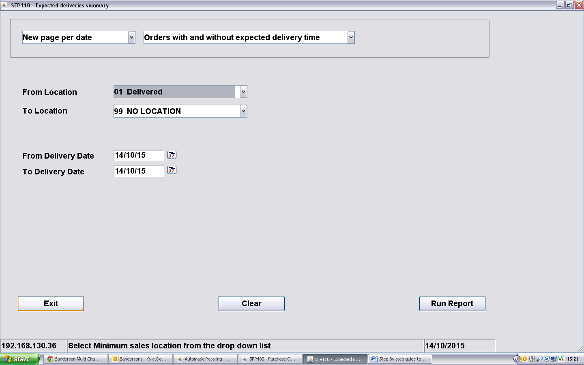
Select the date range you require.
Then select “Run Report”
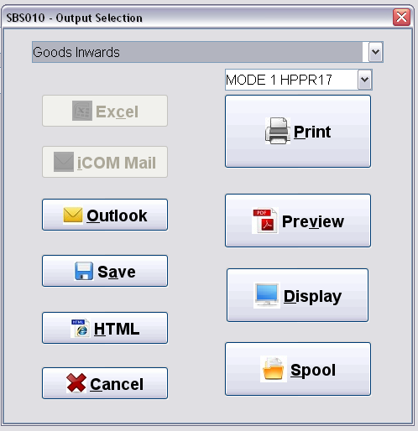
You will then be shown a set of options called “Output Selection”. Select Printer “warehouse” from list. Click “Print”
You will now have your Expected delivery summary; this can be printed as many times as you need and at any time of day.

SFP400 Purchase Order Printing
If you receive a delivery note and have no purchase order note or number you can search for and print the correct purchase orders.
Run SFP400
You will be prompted to select a printer, you should already have “warehouse” selected, click “print”.

You will then see the following:
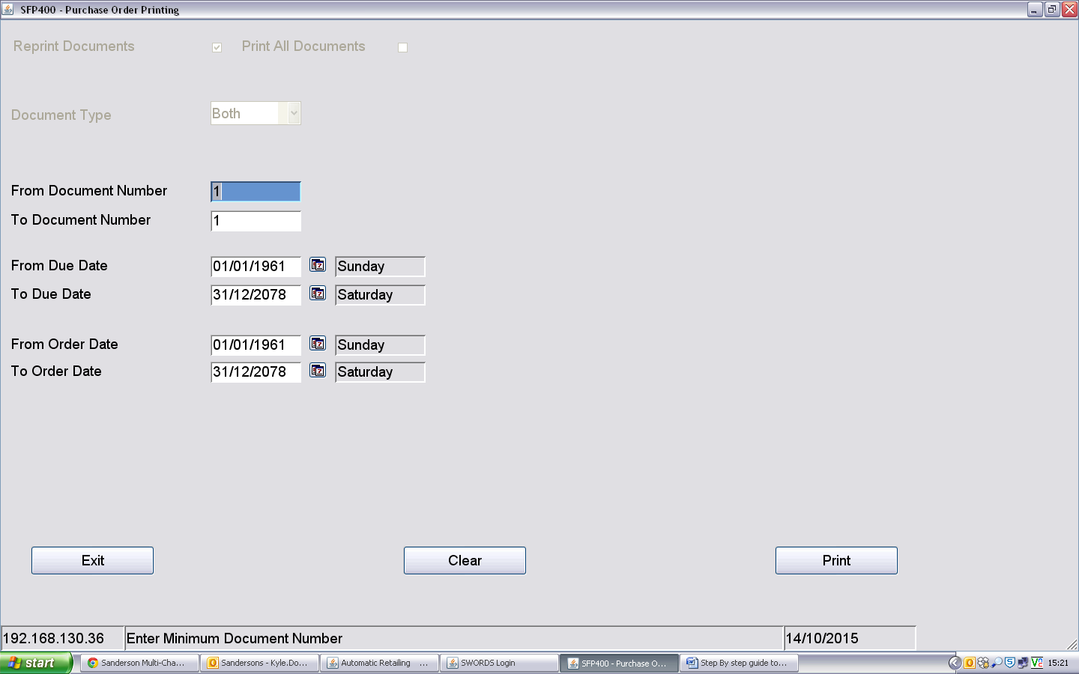
If the purchase order is known enter it in both document number boxes, “from” and “To”.
If you want to print the PO’s to match the expected delivery report, clear the document boxes and enter the dates required in the “Due Date” boxes only (“From” and “To”)

SFD001 Product Information =
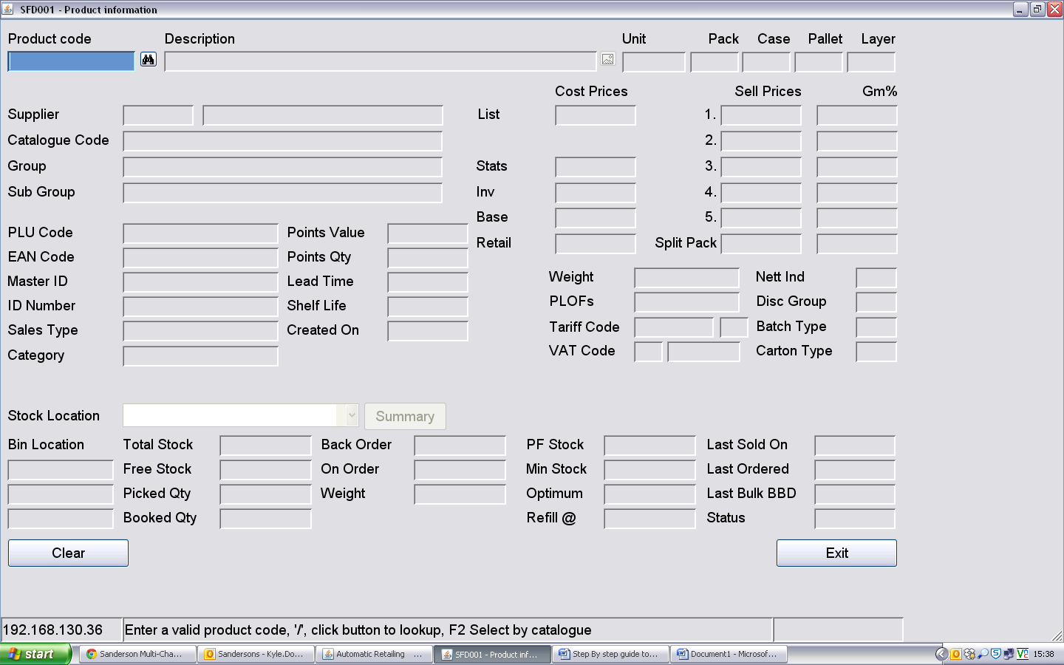
This can be used to find product codes if a scanned barcode is unrecognised, and to check stock levels.
Select the binoculars next to product code in the top left of the screen.
This will give you your search options; enter part or the entire product name in “description” to search the system.
Double click the product line that matches the product to get the full details including product code.

Booking Goods in =
At the end of day remove batteries and place in charger unit for the next morning.
Start of day, insert batteries, and press the PWR button and allow a minute to load up.
You will then be prompted to Log In: SQMN
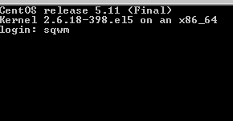
Then enter your Operator number and password, your name will appear confirming your number.
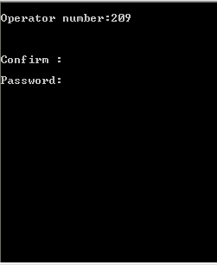
Confirm: Y

The following menu will appear:
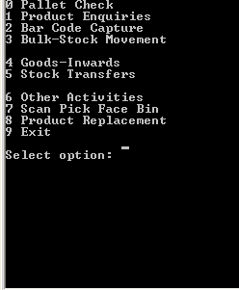
Enter “4” for Goods-Inwards

Goods-in Utilities
Enter “1” for Receipts (from PO), when you have the purchase order.
Enter “2” for Receipts (No PO) if you do not have the purchase order.
Enter “3” to return to main menu.
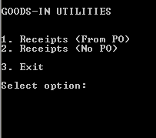

Receipts (from PO)
The first Prompt will be for the Purchase order number, found either on the supplier’s delivery note or on the Printed Purchase order note. Enter the order number.
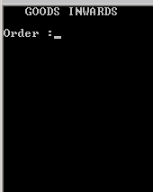
After entering order number;
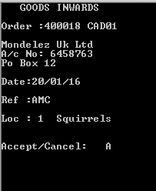
Check the details match the supplier’s delivery note. And press “A” to continue or “C” to go back to order number entry.
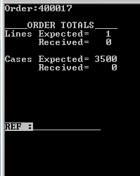
Check the lines expected (number of different products coming in) and check the cases expected(total number of cases on delivery) then enter the suppliers document number/delivery note number to tie in the purchase order to the delivery note.
If no delivery note available, leave any references already entered in place, and press enter.
Select “Y” to continue into order or “N” to return to order number entry.
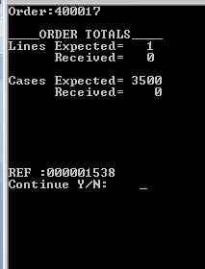
The first prompt will be for the Barcode. Working from the SUPPLIERS DELIVER NOTE, scan the first product barcode. The product details will appear. IMPORTANT! CHECK THE PRODUCT DETAILS MATCH WHAT YOU ARE SCANNING, IF DIFFERENT TO THE PRODUCT CONTACT YOUR SUPERVISOR.
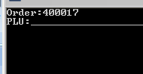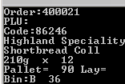
If goods are correct enter case quantities you are booking in, press enter then enter the best before date. Press enter again, and finally confirm order by entering “A” to accept or “C” to cancel and return to case quantity and repeat the above. After you have pressed “A” you will be returned to the PLU;… scanning screen to scan the next barcode. You will also be shown the last product you scanned and the quantity you entered.
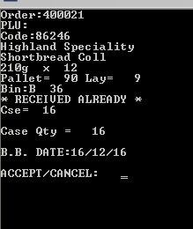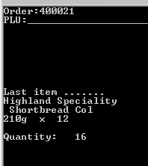

Alternatively, use the following functions:
CTL + E = Suspend Order
CTL + F = Cancel Goods in Receipt.
CLR = Complete goods in receipt
If Scanned barcode has not been recognised, press enter and you will be notified and given the option to enter Product code. Select “Y” to continue or “N” to return to “PLU:..” Barcode scanning. Check the Purchase order for the product code, or request the product code from your supervisor. Then enter Product code.
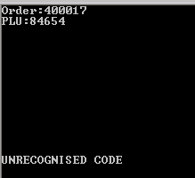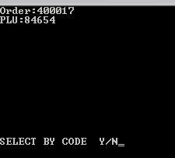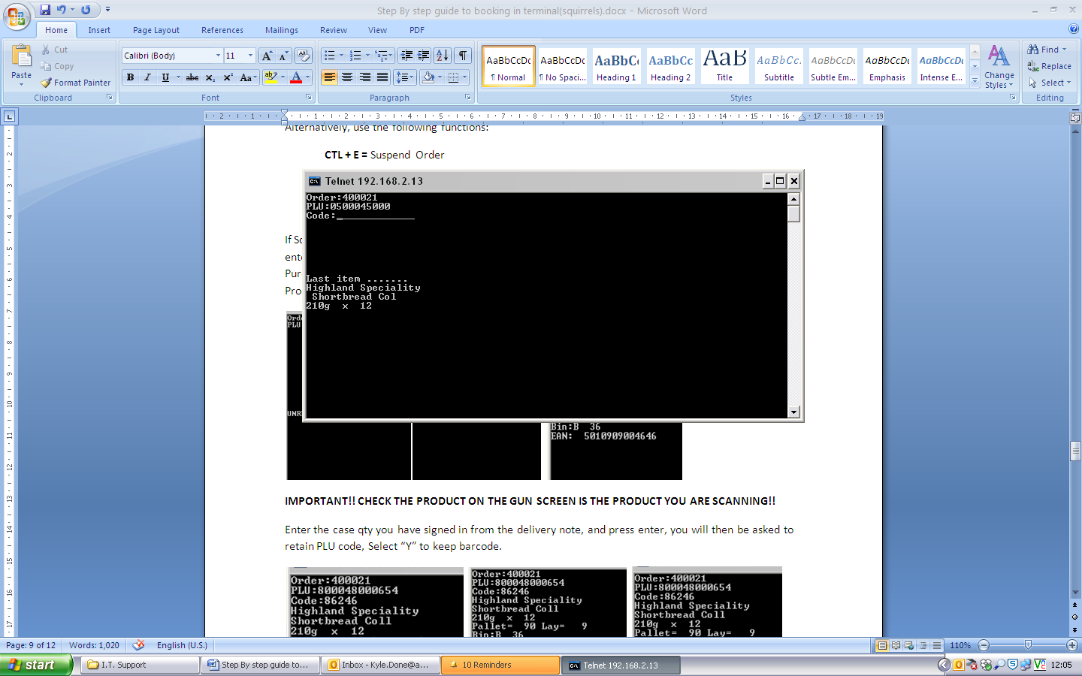
IMPORTANT!! CHECK THE PRODUCT ON THE GUN SCREEN IS THE PRODUCT YOU ARE SCANNING!!
If it is a different product notify your supervisor.
Enter the case qty you have counted and press enter, you will then be asked to retain PLU code, Select “Y” to keep barcode.
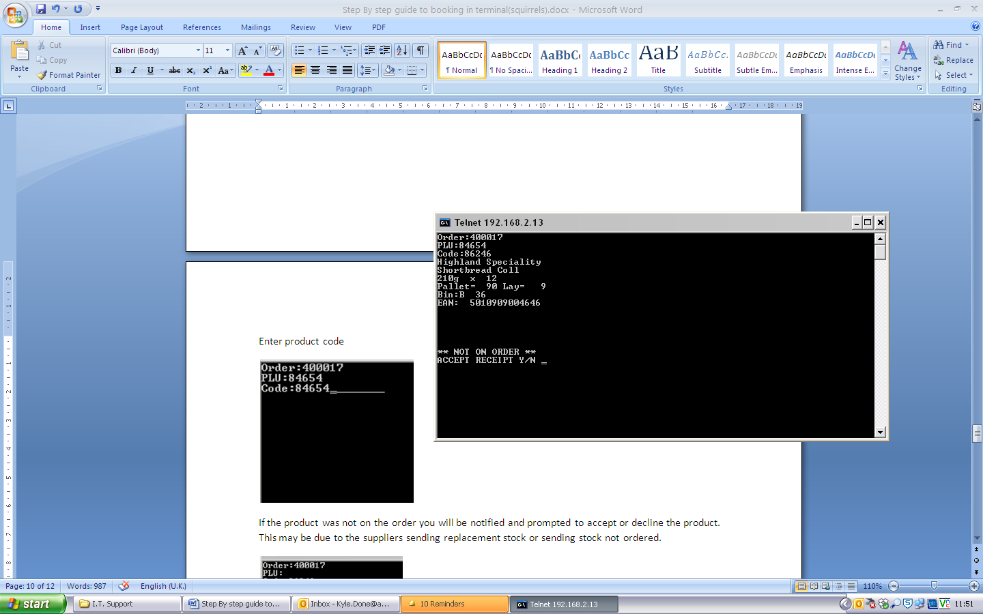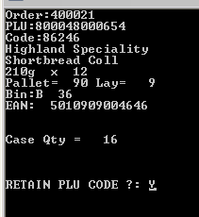

Then Enter the best before date, and either “A” to accept or “C” to cancel.
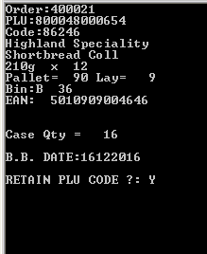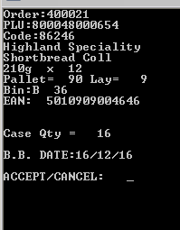
If the product was not on the purchase order you will be notified and prompted to accept or decline the product. This may be due to the suppliers sending replacement stock or sending stock not ordered. Select “Y” to continue a follow the normal booking in procedure.
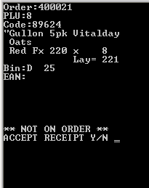
Trouble shooting
*If you scan and enter a product twice or over state the qty, re-scan again and enter a minus qty: FUNC + B then the qty you want to deduct.
*If you haven’t entered enough on the qty re-scan the product and add the difference, following the normal goods in procedure.
*If you enter a QTY or date wrong, either cancel the product line at the end of entry or press BKSP and re-enter. Otherwise, the replenishment team will correct the date when they move stock from goods in to bulk racking.

Completing the goods receipt.
Once the Products have all been entered Press CLR the receipt summary will be shown as follows
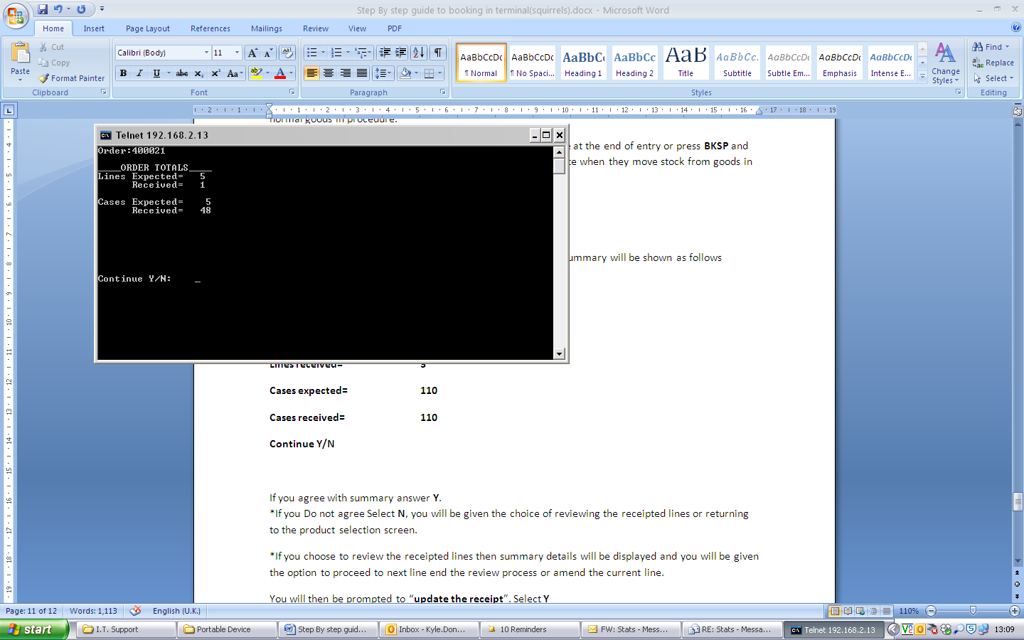
If you agree with summary answer Y.
*If you Do not agree Select N, you will be given the choice of reviewing the receipted lines or returning to the product selection screen.
*If you choose to review the receipted lines (Y) then summary details of the order will be displayed and you will be given the option to proceed to next line(N) or end the review process(E)
*If you select N again you will be returned to the PLU barcode scanning screen to continue scanning the products.
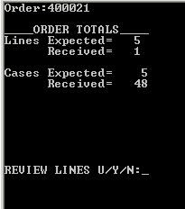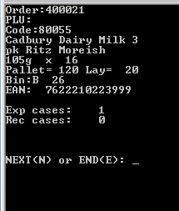
After Selecting “Y” to complete an order you will then be asked if printed ok, Select “Y”
Then select “Y” to update Receipt, which adds the product to the system and back office.
Then Select “Y” to “put away to bulk” (goods in area)
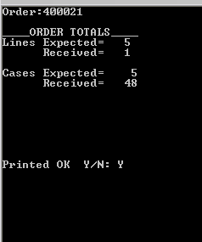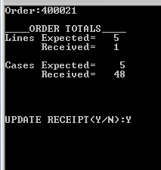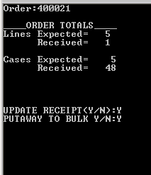
Once the Order is complete the GRN and exceptions report will be printed in warehouse office.
Staple these with the purchase order and delivery note before handing in.

Please sign to confirm you understand and have been trained in booking goods in.
Name ………………………………………….. Supervisor…………………………….
Signed…………………………………………….. Signed…………..……………………….
Date……………………………………………….. Date……………….……………………..

