Capture Barcodes
At the end of day remove batteries and place in charger unit for the next morning.
Start of day, insert batteries, and press the PWR button and allow a minute to load up.
You will then be prompted to Log In: SQMN
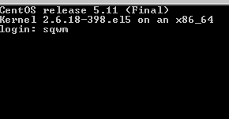
Then enter your Operator number and password, your name will appear confirming your number.
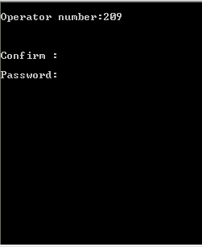
Confirm: Y
The following menu will appear:
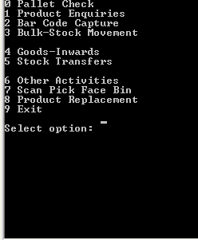
Enter “2” for Bar Code Capture

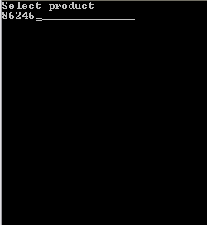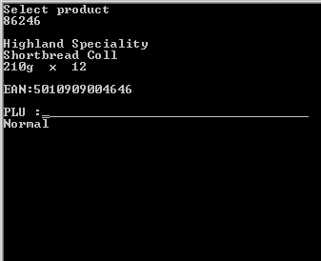
Key in the Product code of the product you are capturing. Press enter. Check the product details are correct and match the product you are capturing, if different, press “CLR” key to escape. Report the difference to your manager. 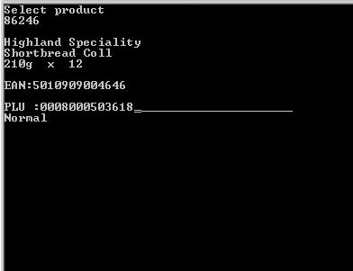 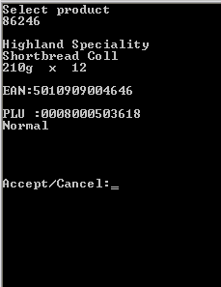
If product details are correct scan the products outer barcode and check the full barcode number has been captured. Press enter, then “A” to accept or “C” to cancel.
After pressing “C” you can Scan the barcode again or press “CLR” to exit and return to product number entry.
After pressing “A” to accept the new barcode, Press “CLR” key to escape back to product number entry screen and “CLR” again to exit to menu.
*IMPORTANT!! PRESS “CLR” TO EXIT BARCODE CAPTURE AFTER ACCEPTING OTHERWISE THE NEXT BARCODE YOU SCAN WILL BE ADDED TO THE PRODUCT. ANY ERRORS WHEN SCANNING MUST BE REPORTED TO YOUR MANAGER IN ORDER TO CORRECT THE MISTAKE.

Please sign to accept that you understand and have completed the training on the above.

Name ……………………………………………………… Managers Name………………………………………
Signature………………………………………………… Managers Signature………………………………..
Date………………………………………………………… Date…………………………………………………………

