Goods-in to bulk racking.
At the end of day remove batteries and place in charger unit for the next morning.
Start of day, insert batteries, and press the PWR button and allow a minute to load up.
You will then be prompted to Log In: SQMN
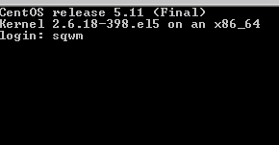
Then enter your Operator number and password, your name will appear confirming your number.
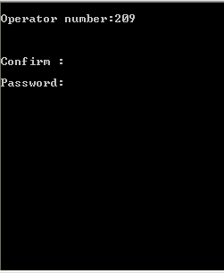
Confirm: Y
The following menu will appear:
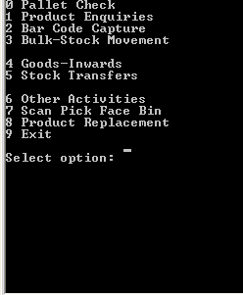
Enter “3” for Bulk-Stock Movement

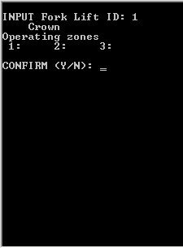
Enter “1” for fork lift ID, press Enter press Enter again and “Y” to confirm and continue to the next screen.
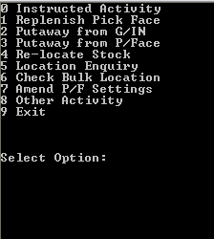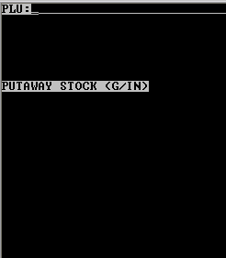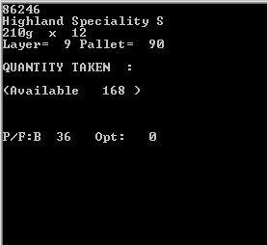
Select option “2” put away from G/IN. Scan your product. Check product details with the product you are scanning if correct continue, if different contact your manager and press “CLR” to return to PLU scanning.
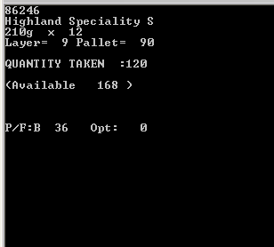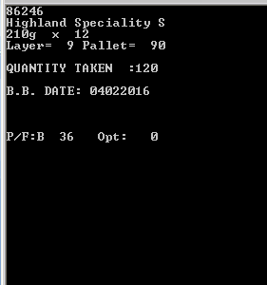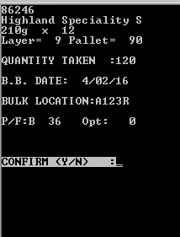
As you can see the available quantity is shown as a total amount in the Goods-in area, Only enter the quantity you are going to move from Goods-in. Enter the Best Before Date on the product. Scan the location barcode to put away to bulk racking. Check your details are correct and press “Y” to complete move, this will return you to the PLU scanning screen ready to scan the next product. If your details are incorrect select “N”, this will return you to the bulk location option.
To go back to the date press “CLR” , Press “CLR” again to return to quantity taken, Press “CLR” again to return to PLU scanning, and press “CLR” to exit to menu.

Goods-in to Pick face.
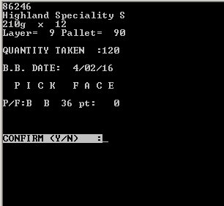
To move from goods-in to pick face location directly, follow the above as normal but when asked for Bulk location select “CTL” and “B” this will change the option for Bulk location to PICK FACE, confirm “Y” or select “N” to go back. Then move the stock straight into its pick face.

You will be given a report at the start of day showing you where the stock needs to be taken from and where it needs to be put away. Seek your manager for a copy of “Stock movement instructions” (SFC120).

*When dealing with split pallets you will need to repeat the process for each product line on the pallet.
*When dealing with different dates on the same product move the quantity with the same date only then repeat the process with the next date and so on.

Please sign to accept that you understand and have completed the training on the above.
Name ……………………………………………………… Managers Name………………………………………
Signature………………………………………………… Managers Signature………………………………..
Date………………………………………………………… Date…………………………………………………………

