Pick face amendments.
At the end of day remove batteries and place in charger unit for the next morning.
Start of day, insert batteries, and press the PWR button and allow a minute to load up.
You will then be prompted to Log In: SQMN
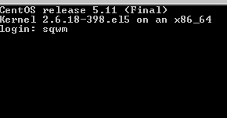
Then enter your Operator number and password, your name will appear confirming your number.
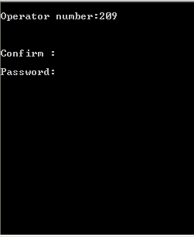
Confirm: Y
The following menu will appear:
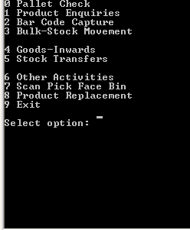
Enter “7” for Scan Pick Face Bin

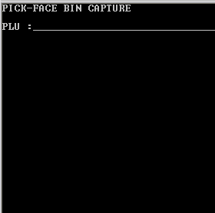.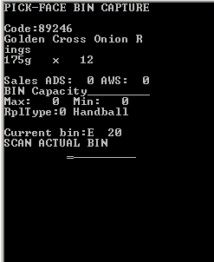
Scan product in pick face location.
Check Product details against the actual product scanned. If details match continue. If the details are different contact your manager to query the product. Press “CLR” to exit.
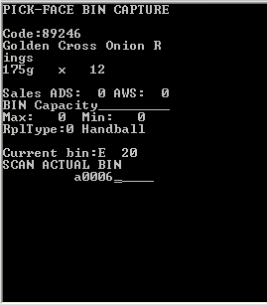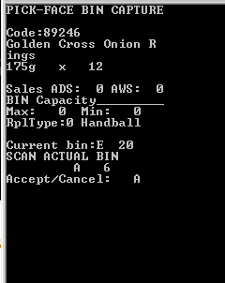
Check the Current bin number, if correct press “CLR” to exit, if pick face is wrong manually key in the correct pick face location. The numbers are 4 digits, e.g. Pick location A6 in the above example would be entered as a0006. Select “A” to confirm pick face location or “C” to return to PLU scanning.

Please sign to accept that you understand and have completed the training on the above.
Name ……………………………………………………… Managers Name………………………………………
Signature………………………………………………… Managers Signature………………………………..
Date………………………………………………………… Date…………………………………………………………

