Move goods from pick face to bulk racking.
At the end of day remove batteries and place in charger unit for the next morning.
Start of day, insert batteries, and press the PWR button and allow a minute to load up.
You will then be prompted to Log In: SQMN
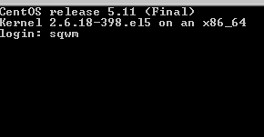
Then enter your Operator number and password, your name will appear confirming your number.
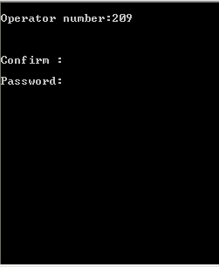
Confirm: Y
The following menu will appear:
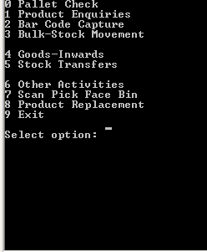
Enter “3” for Bulk-Stock Movement

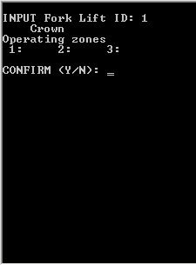
Enter “1” for fork lift ID, press Enter press Enter again and “Y” to confirm and continue to the next screen.
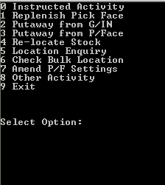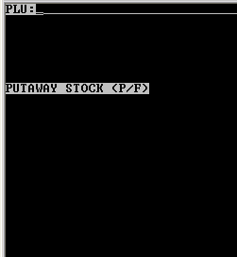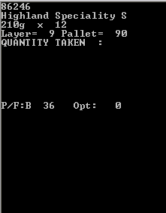
Select “3” put away from P/Face. Scan the product barcode and check the product details and pick face location, if incorrect check with your manager to investigate, and enter “CLR” to return to PLU scanning. Press “CLR” again to exit to main menu.
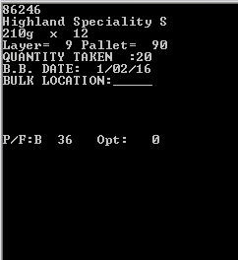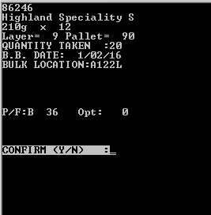
Enter the quantity you are moving to bulk, Press “BKSP” to re-enter if wrong. Press Enter to continue.
Enter the best before date, Press “BKSP” to re-enter if wrong. Enter to continue.
Scan the Bulk location and select “Y” if correct and you will be returned to the PLU scanning screen. Press ”CLR” to exit to menu.
Select “N” to return to bulk location and re-scan.
If details are wrong, press “CLR” again to return to date.
If details are wrong, press “CLR” again to return to Quantity.
If details are wrong, press “CLR” again to return to PLU scanning.
Press “CLR” again to exit.

Please sign to accept that you understand and have completed the training on the above.
Name ……………………………………………………… Managers Name………………………………………
Signature………………………………………………… Managers Signature………………………………..
Date………………………………………………………… Date…………………………………………………………

