Relocating Bulk stock.
At the end of day remove batteries and place in charger unit for the next morning.
Start of day, insert batteries, and press the PWR button and allow a minute to load up.
You will then be prompted to Log In: SQMN
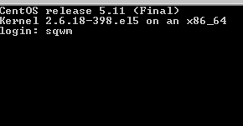
Then enter your Operator number and password, your name will appear confirming your number.
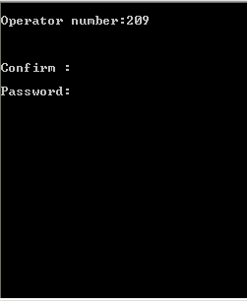
Confirm: Y
The following menu will appear:
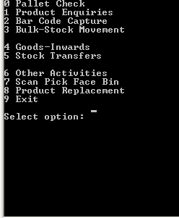
Enter “3” for Bulk-Stock Movement

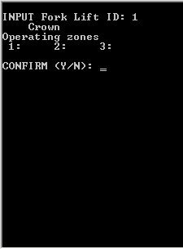
Enter “1” for fork lift ID, press Enter press Enter again and “Y” to confirm and continue to the next screen.
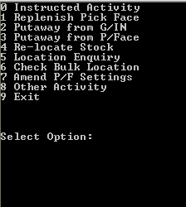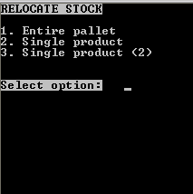
Select “4” to relocate stock. This is used to move bulk locations to other bulk locations.
You will be given 3 options. It is very important to understand the difference between them.

- Entire pallet. This option allows you to move all products in a bulk location to another Bulk location
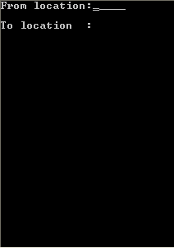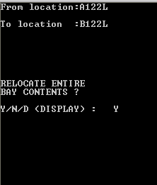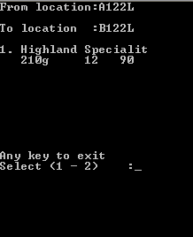
Scan the location you are moving, and them scan the target location. You are the asked to confirm “Y”, or to cancel ”N” or “D” display all products in the location you are moving. Press”CLR” at any point to return to location scanning, and “CLR” again to return to options and “CLR” again to exit to main menu.

- Single Product. This is used to move all quantities of the same product in a bulk location to another bulk location.
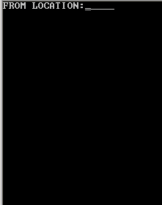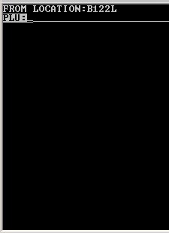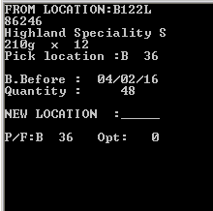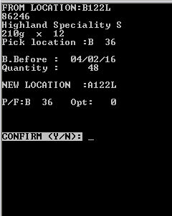
Scan location barcode you are taking products from. If there are multiple products in the location you will be asked to scan the product barcode as well. Scan the new location barcode and enter “Y” to confirm or “N” to cancel returning you to the location barcode scanning. Press “CLR” at any point to return to location barcode scanning, and press “CLR” again to return to menu.

- Single Product (2) – This is used to move a selected quantity of a single product from a bulk location to another bulk location
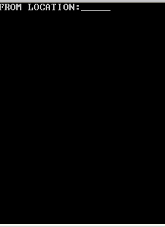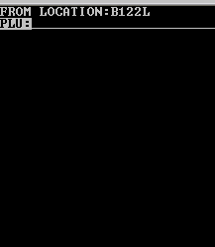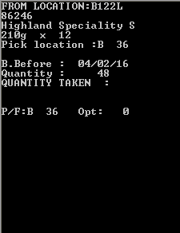
Scan the location barcode you are moving from. Then scan the product barcode you wish to move. Check the product details and quantity are correct. If they are wrong contact you manager to investigate.
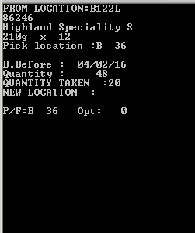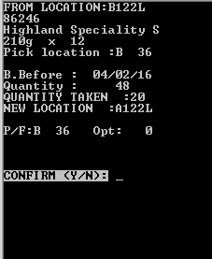
Enter the quantity you are moving, and then scan the location barcode you are moving the product to.
Enter “Y” to confirm or “N” to cancel returning you to the location barcode scanning screen.
Entering “CLR” at any point will return you to the beginning and entering “CLR again will exit to the main menu.

Please sign to accept that you understand and have completed the training on the above.
Name ……………………………………………………… Managers Name………………………………………
Signature………………………………………………… Managers Signature………………………………..
Date………………………………………………………… Date…………………………………………………………

