Replenish pick face from Bulk racking
At the end of day remove batteries and place in charger unit for the next morning.
Start of day, insert batteries, and press the PWR button and allow a minute to load up.
You will then be prompted to Log In: SQMN
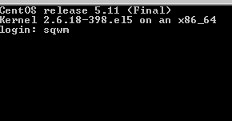
Then enter your Operator number and password, your name will appear confirming your number.
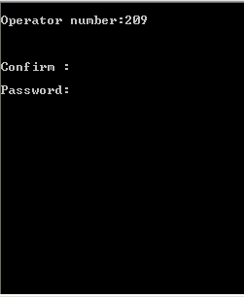
Confirm: Y
The following menu will appear:
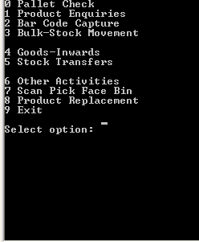
Enter “3” for Bulk-Stock Movement

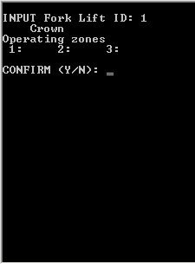
Enter “1” for fork lift ID, press Enter press Enter again and “Y” to confirm and continue to the next screen.
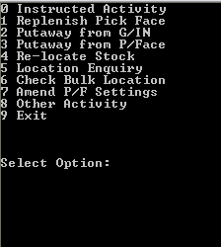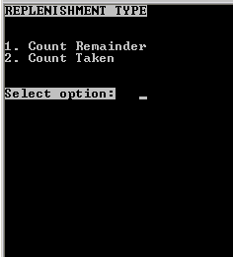
Enter “1” for Replenish Pick Face. Always select option 2. Count taken
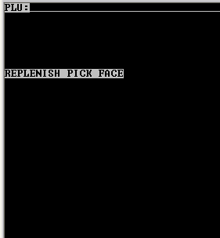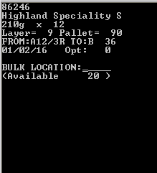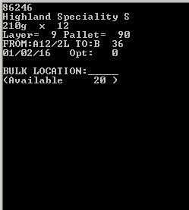
Scan product barcode to replenish. Check product details are correct and match the product you are scanning.
If the details are incorrect or unrecognised then contact your manager to investigate.
The first location to move from bulk will be the shortest best before date. Should you need to go to the next Bulk location press the “CTL” key and “B”, continue pressing these 2 keys to cycle through the available bulk locations including Goods-in which will show the location number 0/0. You will also be shown the Pick face location to move the stock to. And how many are available to be moved.

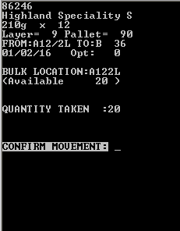
Confirm the Bulk location by scanning the location barcode you took the goods from.
Confirm the Qty you are moving to pick face, Press “BKSP” to correct entry if wrong.
Finally Accept the replenishment by selecting “A”. Select C to Cancel returning you to the PLU scanning screen. And “CLR” to exit.

Please sign to accept that you understand and have completed the training on the above.
Name ……………………………………………………… Managers Name………………………………………
Signature………………………………………………… Managers Signature………………………………..
Date………………………………………………………… Date…………………………………………………………

