Picking list amendment
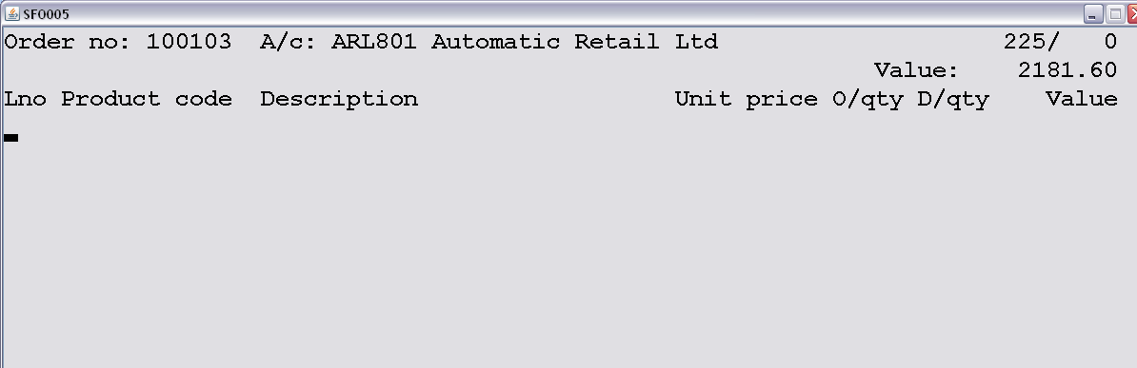
Press F4 to review the current line numbers, products and confirmed Delivery quantities (D/qty).
EXIT THE REVIEW BEFORE ENTERING “D/qty”. !!!!! IGNORE “SELECT LINE NUMBER!!!!!
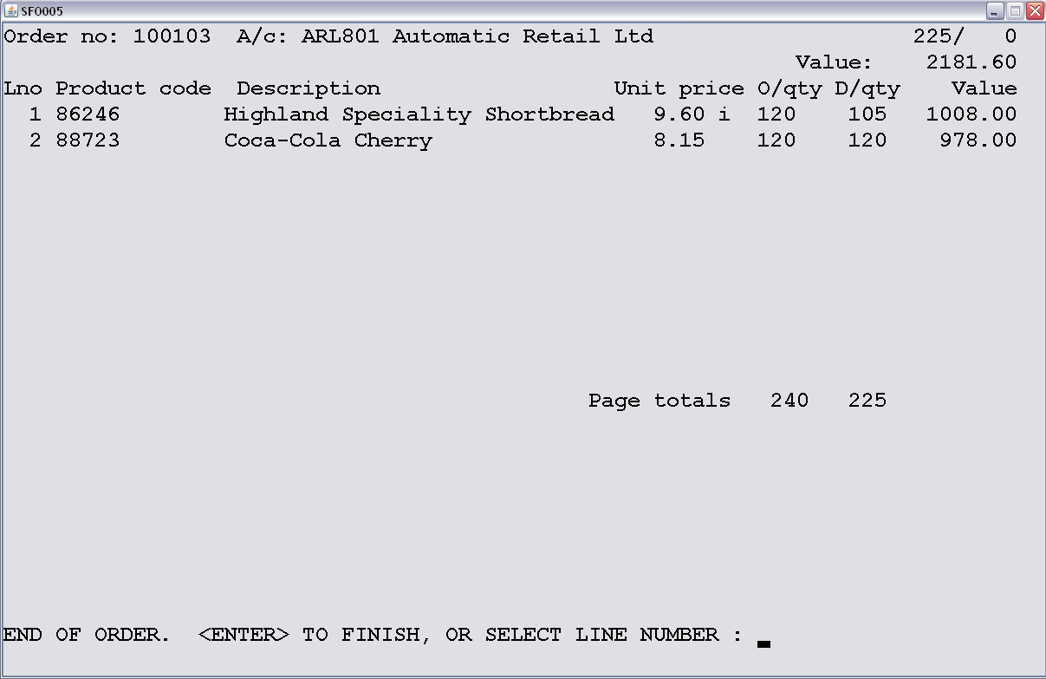
Enter the line number (Lno) & check the product details, then enter the quantity to change the D/QTY value, enter through to the next line entry and repeat the above.
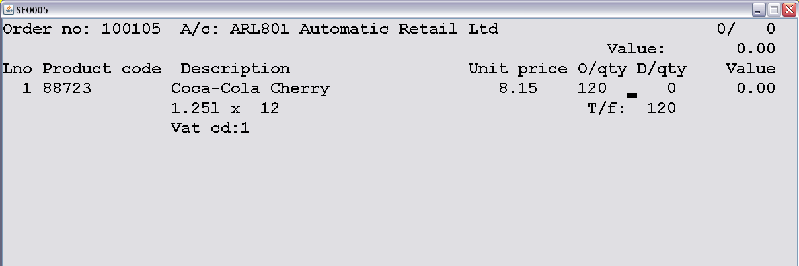
*IMPORTANT!!! IF THE “D/qty” VALUE SHOWS AS “0” BUT THE “PICKED QTY” HAS BEEN ENTERED ON THE PICKING LIST, YOU WILL NEED TO AMEND THE ORDER LINE IN ORDER CONFIRMATION(SFO005) OR THE INVOICE WILL NOT PRINT THE PICKED PRODUCTS.

