Warehouse Management Guides (INVOICE PRINTING)
Checking the picking list.
The picking list sheet shows the customer’s details, order number, order date, number of pages, print date and alternative deliver addresses.
Further down the Picking list shows the products by line number(LINE), pick face bin location(BIN), picked quantity(Picked QTY), Ordered quantity(Ord QTY), Goods in stock(IN Stock), Goods awaiting delivery to follow (T/F), Product code(code), Pack size(Pack size), Product description (Description), Product barcode(barcode).
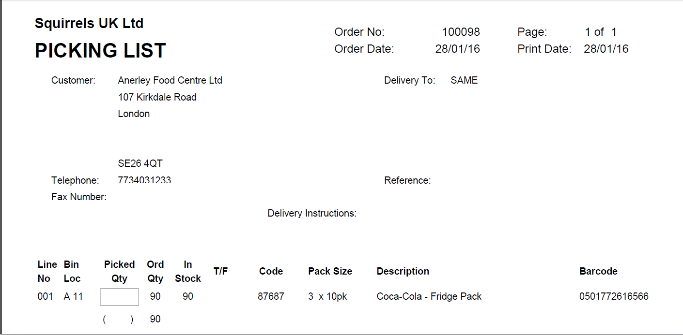
The bottom of the pick sheet shows estimated pallets, who has picked the order (PICKER NUMBER,) who has checked the order (Signed or PICKER NUMBER) and actual pallets picked.
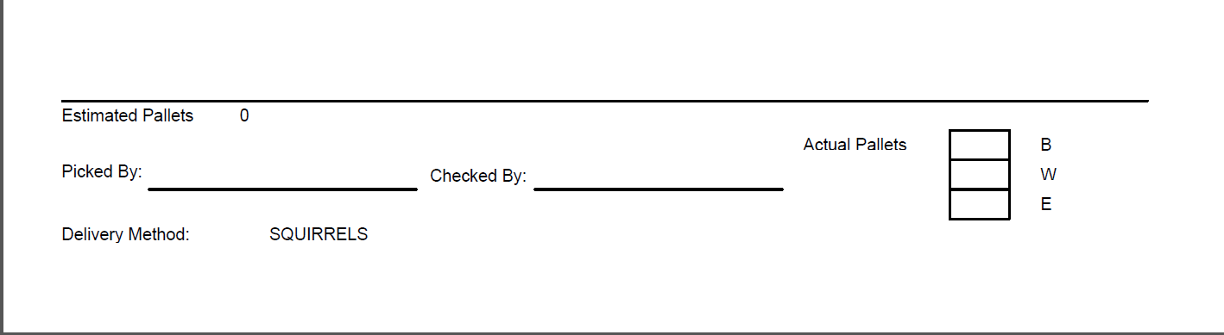

When Checking the Picking list, the “Picked QTY” should match the “ORD QTY”, if it doesn’t this line will need to be amended in the Order confirmation program (SFO005).
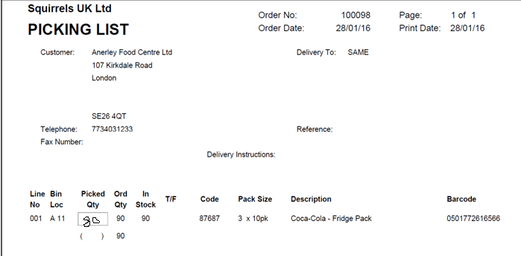
*IMPORTANT!!! IF THE “IN STOCK” VALUE SHOWS AS “0” BUT THE “PICKED QTY” HAS BEEN ENTERED, YOU WILL NEED TO AMEND THE ORDER LINE IN ORDER CONFIRMATION(SFO005) OR THE INVOICE WILL NOT PRINT THE PICKED PRODUCTS.
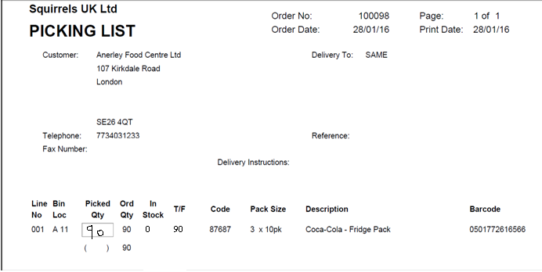

Check the Bottom of the picking list, the “Picked By” and “Checked By” must be entered.
Check the “Actual Pallets” boxes, if no number has been entered you will need to find out how many pallets and what type of pallets have been used.
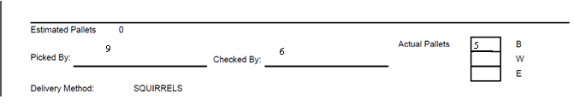

Once the pick sheets have been returned and signed you will need to confirm the order and print the invoice.
In Quick start menu type SFO005 to go straight to program.
On main menu select “Sales order processing”
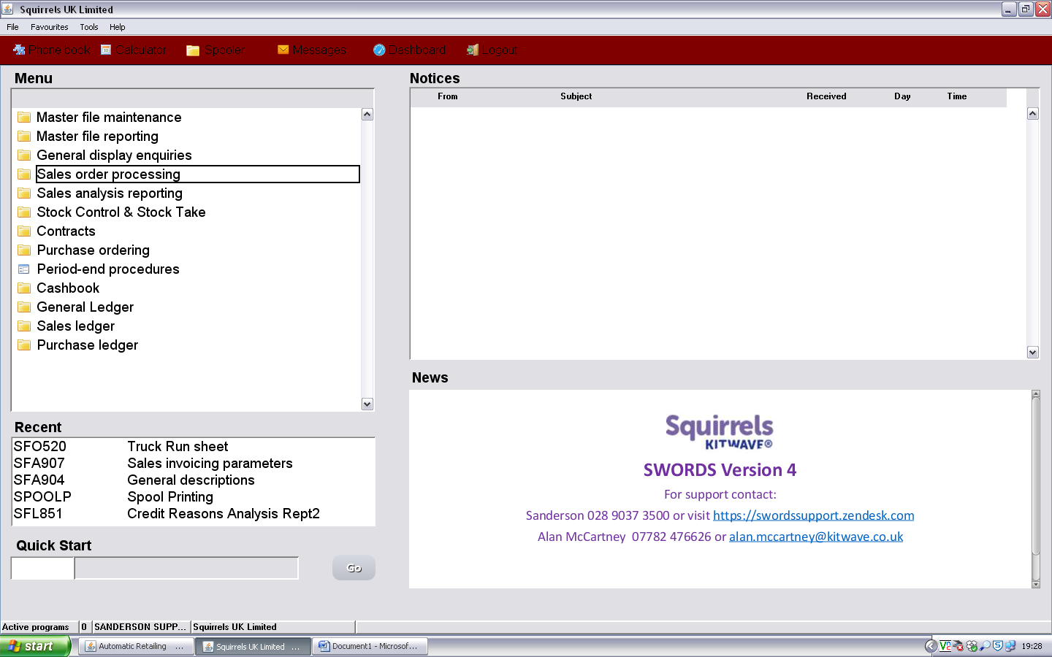
Then select “Delivery confirmation” 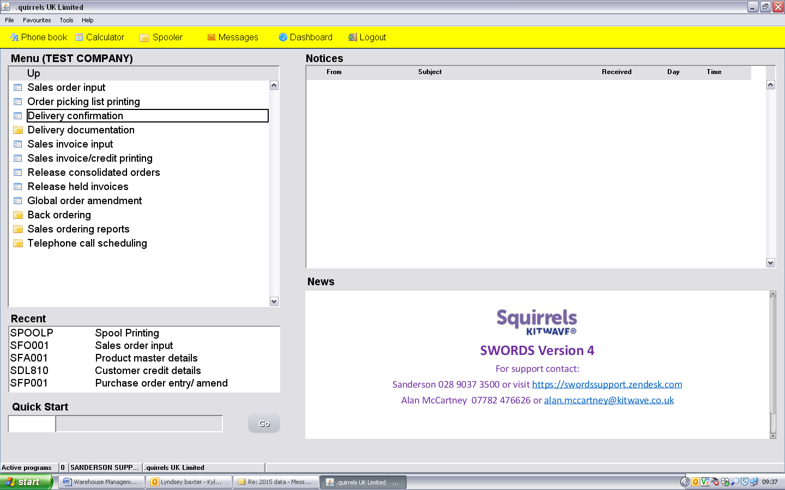
Enter the pick sheet order number or select F4 to view all sales orders, enter to escape, and type in order number.
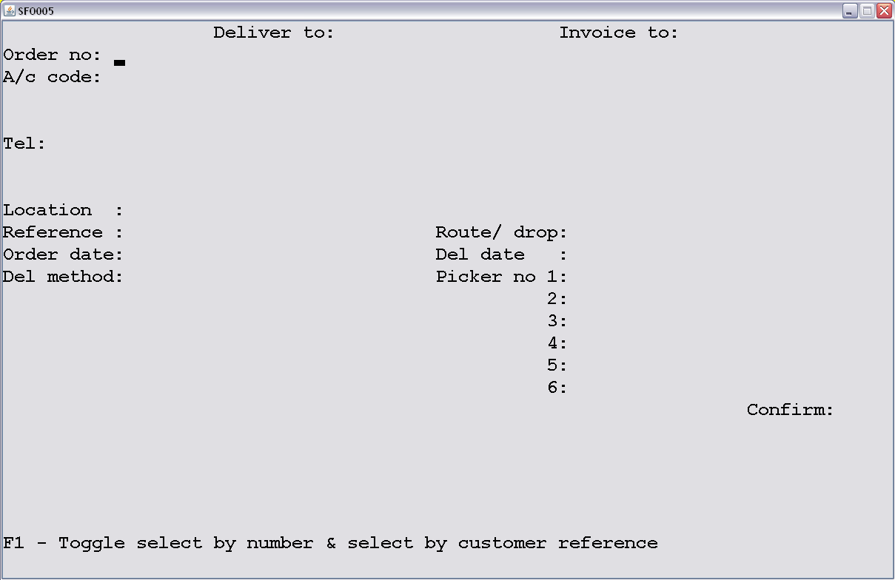
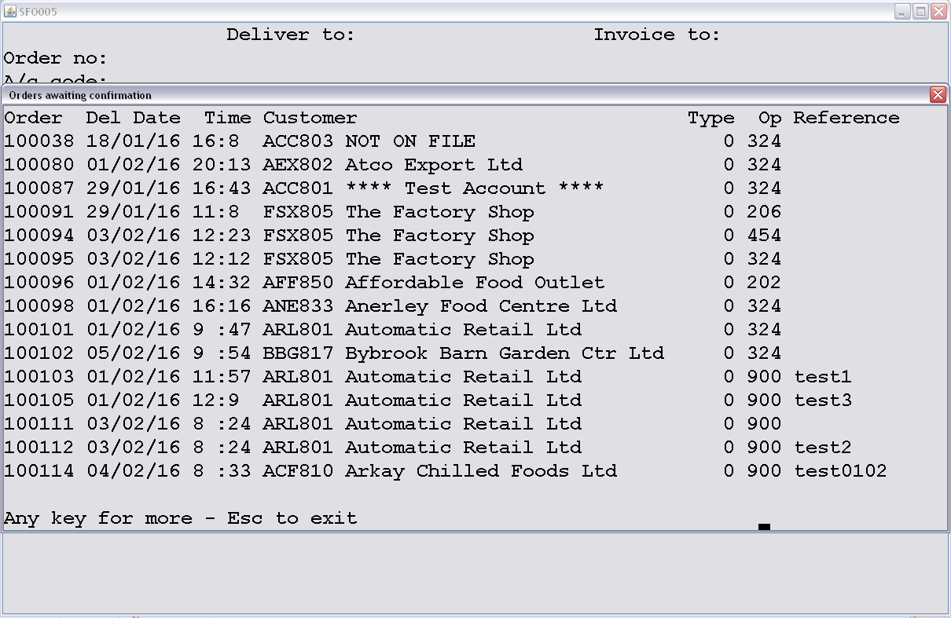
*IMPORTANT, Check the customer’s details match the Picking List before continuing. If you have entered the wrong Order number press “ESC” key.
You will be prompted to change the delivery date, if different enter the correct delivery date and press enter. Enter the picker number(s) and enter down to confirm, and press “Y”
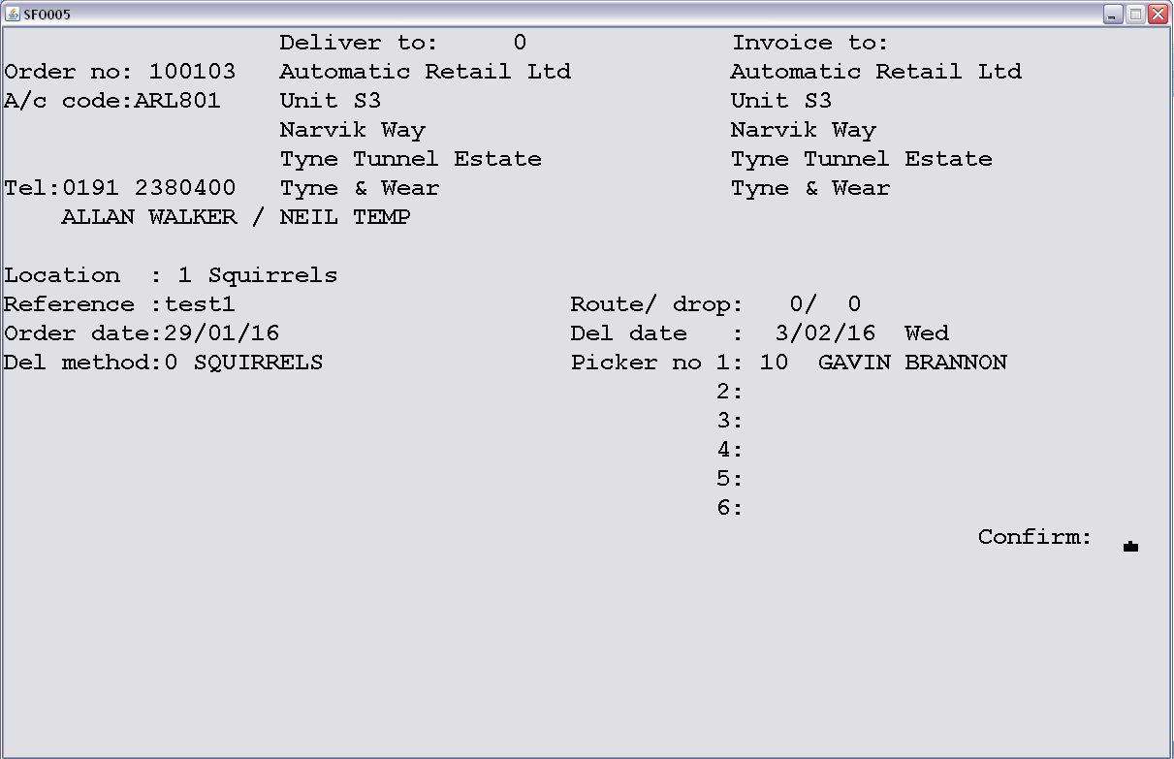

This is where you can amend changes to the picking list. I.e. Goods not available for picking and goods picked not in stock.
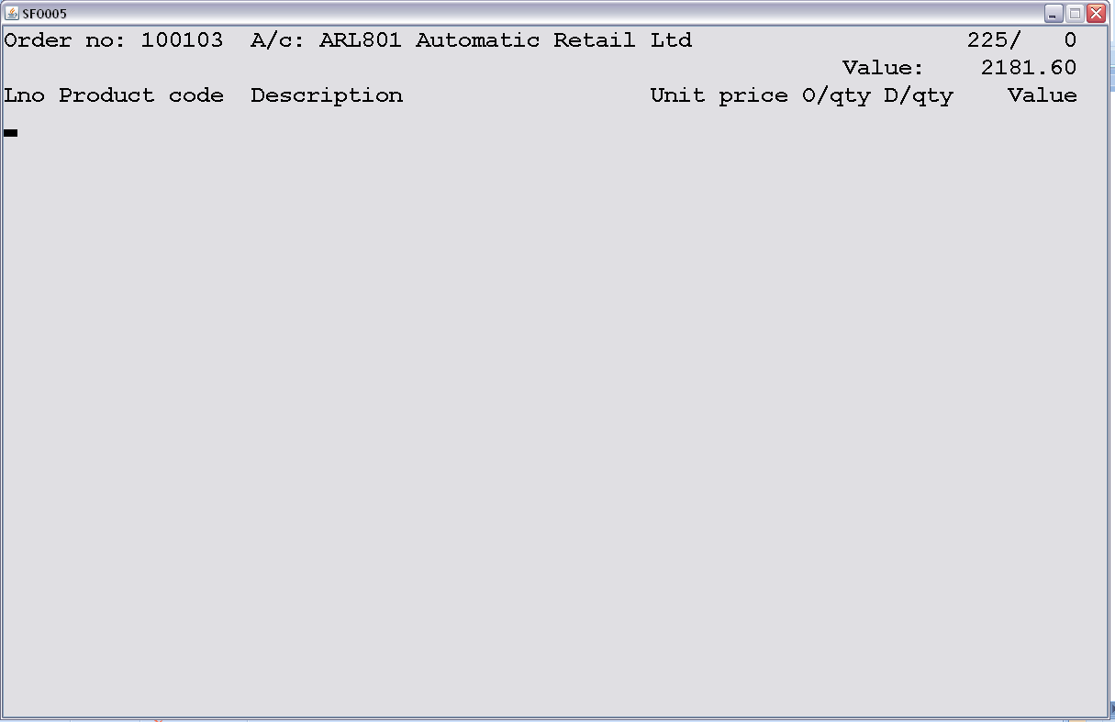
Press F4 to review the current line numbers, products and confirmed Delivery quantities (D/qty).
YOU MUST EXIT THE REVIEW SCREEN BEFORE AMENDMENTS CAN BE MADE!!!! IGNORE “SELECT LINE NUMBER”!!!
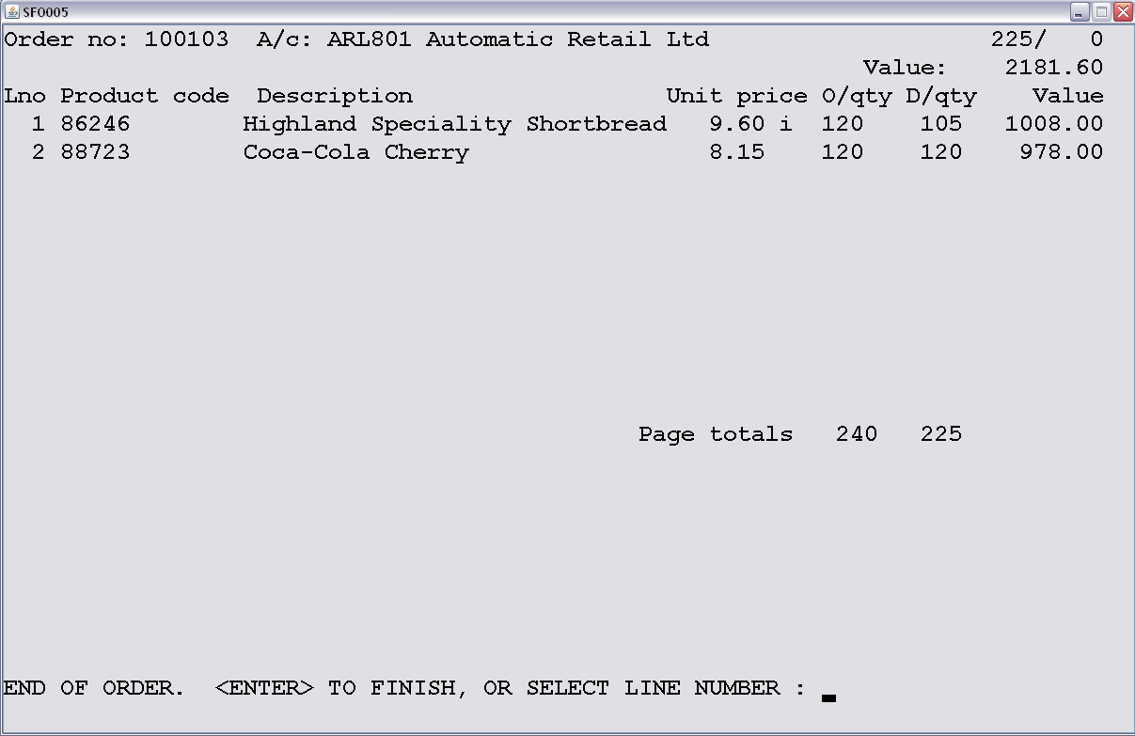

Enter the line number(Lno) & check the product details and enter the number to change the QTY value, enter through to the next line entry.
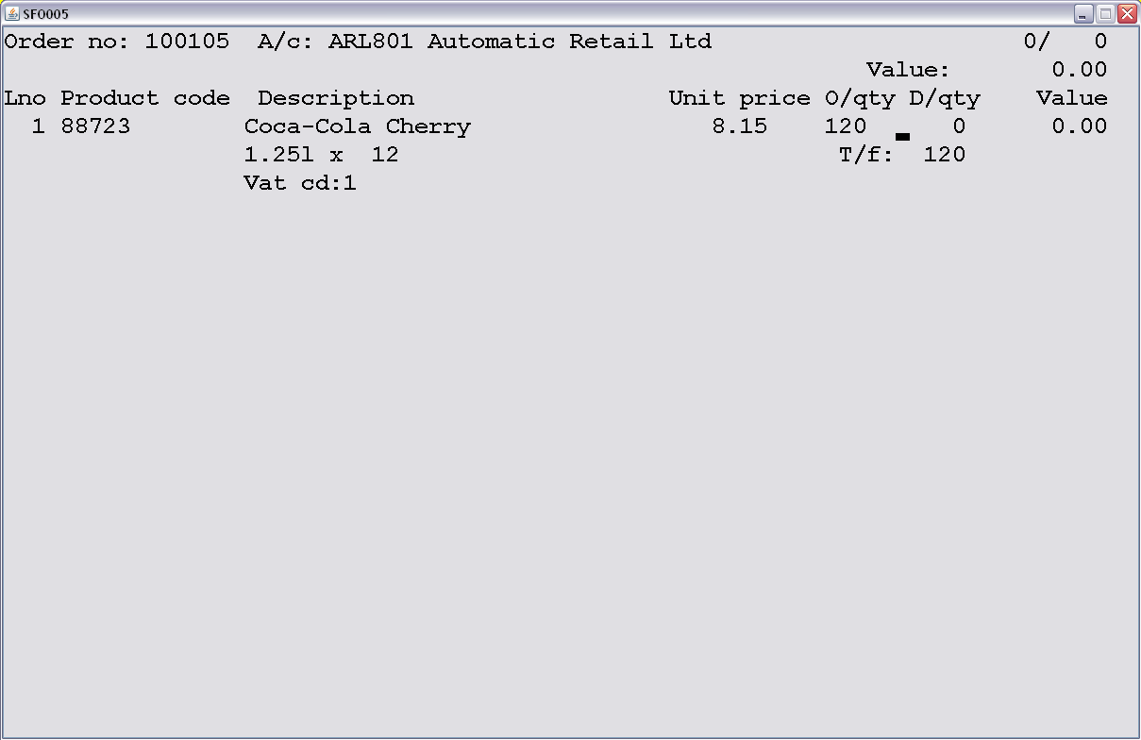
*IMPORTANT!!! IF THE “D/qty” VALUE SHOWS AS “0” BUT THE “PICKED QTY” HAS BEEN ENTERED ON THE PICKING LIST, YOU WILL NEED TO AMEND THE ORDER LINE IN ORDER CONFIRMATION(SFO005) OR THE INVOICE WILL NOT PRINT THE PICKED PRODUCTS.

You have 3 options at this stage;
F6 will delete the confirmation, taking you back to the start where you can re-enter the picking number.
F9 will suspend the order taking you back to the start so that you can return to it later with the changes you may have already made.
F10 will complete the order taking you to the final page.

On the final page you have the option to enter 3 lines of delivery instructions which will be printed on the delivery note.
You can also enter any references needed, and also the pallet numbers that should have been written on the pick sheets.
Enter through to “finish order” this will then complete the order, and automatically print the delivery notes (green and pink paper) and also the invoice (white paper).
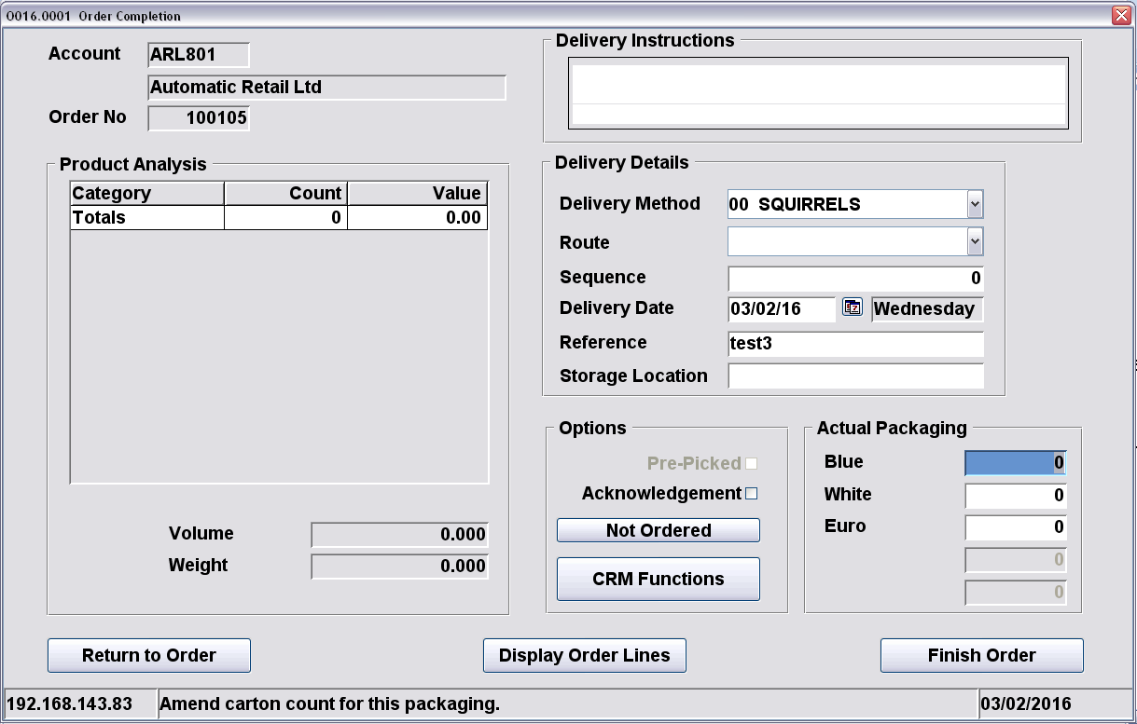
Both the delivery notes and the invoice can be reprinted from the spooler on the main screen
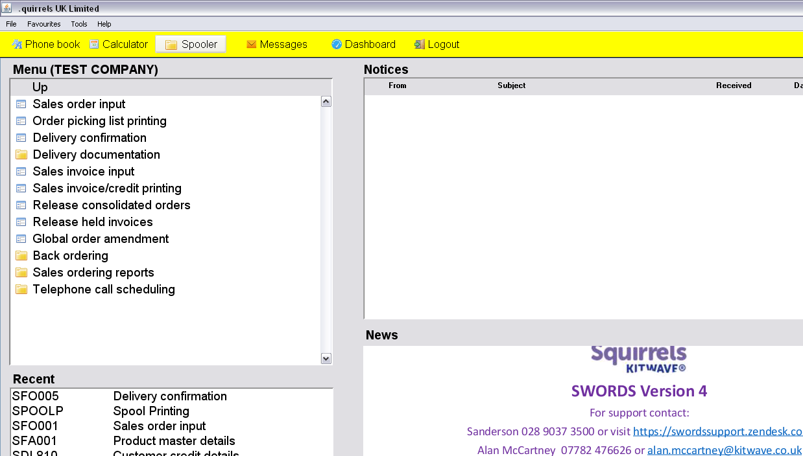

Please sign to accept that you understand and have completed the training on invoice printing.
Name ……………………………………………………… Managers Name………………………………………
Signature………………………………………………… Managers Signature………………………………..
Date………………………………………………………… Date…………………………………………………………

