Expected Delivery Report and Purchase Order Printing.
In Quick start enter SFP110, or from main menu select “purchase ordering” then “expected delivery report.
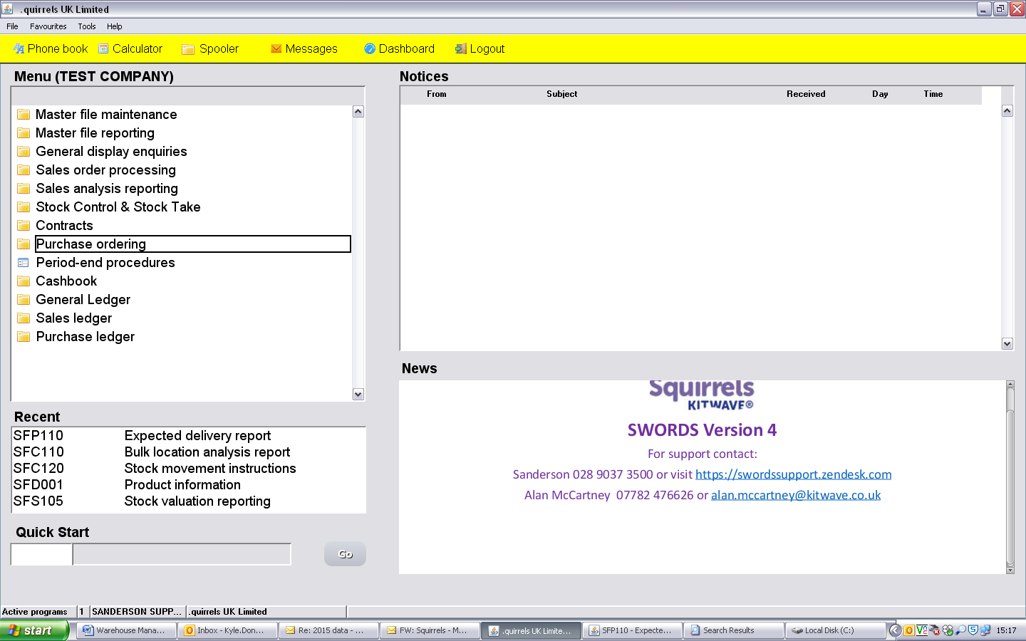
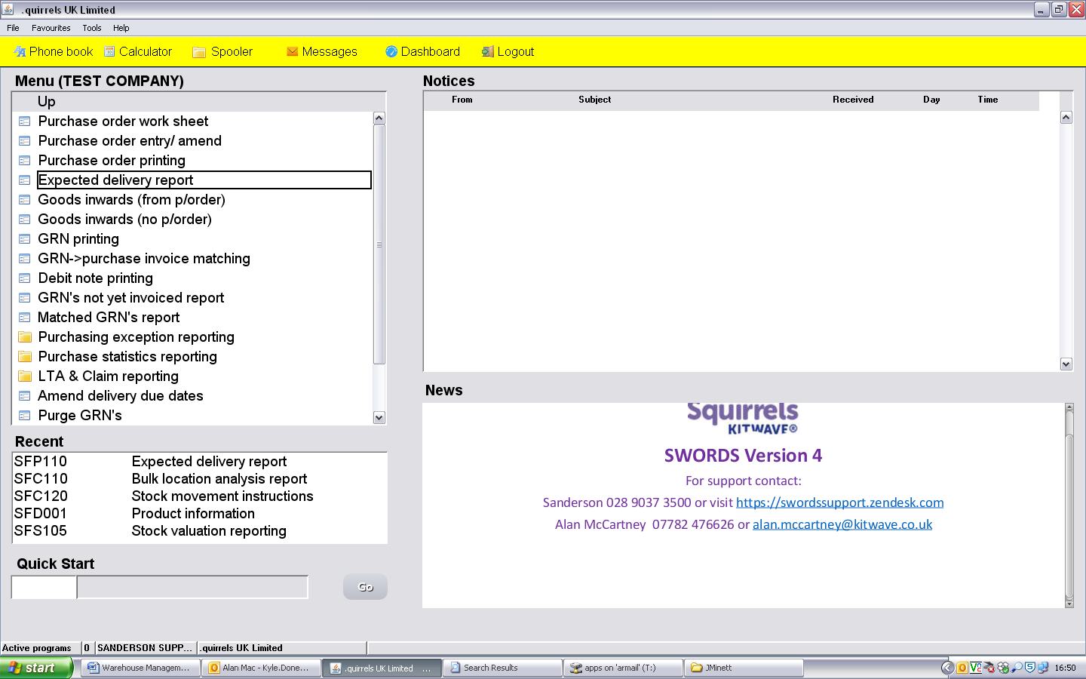
Select Orders with expected delivery time, and Location squirrels to squirrels, and then select the date range. Finally select run report.
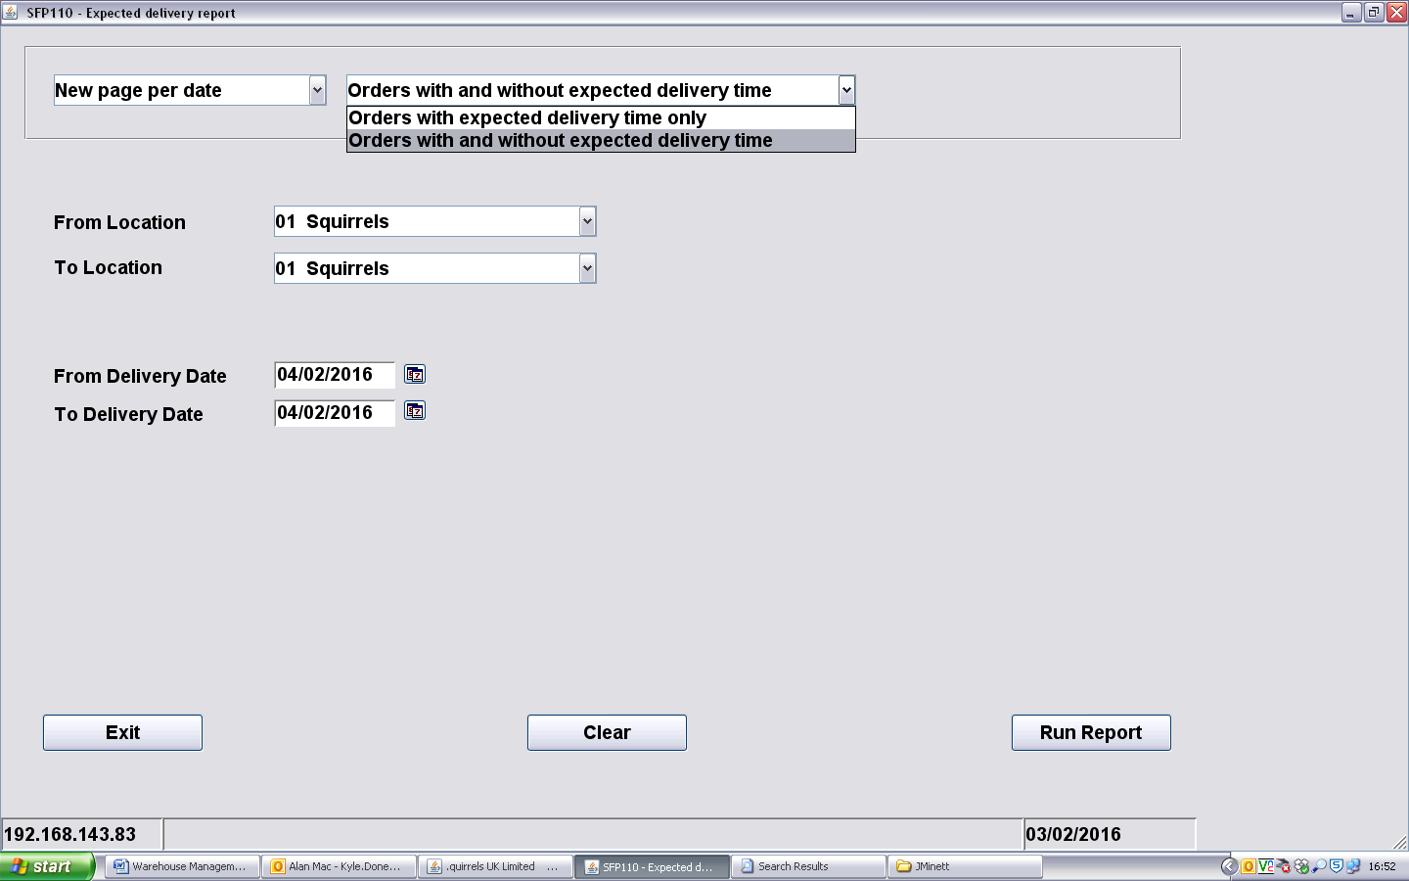
You will then be asked for output selection. Either choose the Warehouse printer, or select display to see on screen.
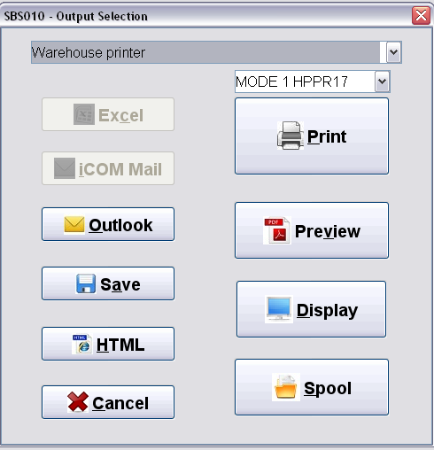

Purchase order Printing
Either select “Purchase ordering” on menu or quick start SFP400
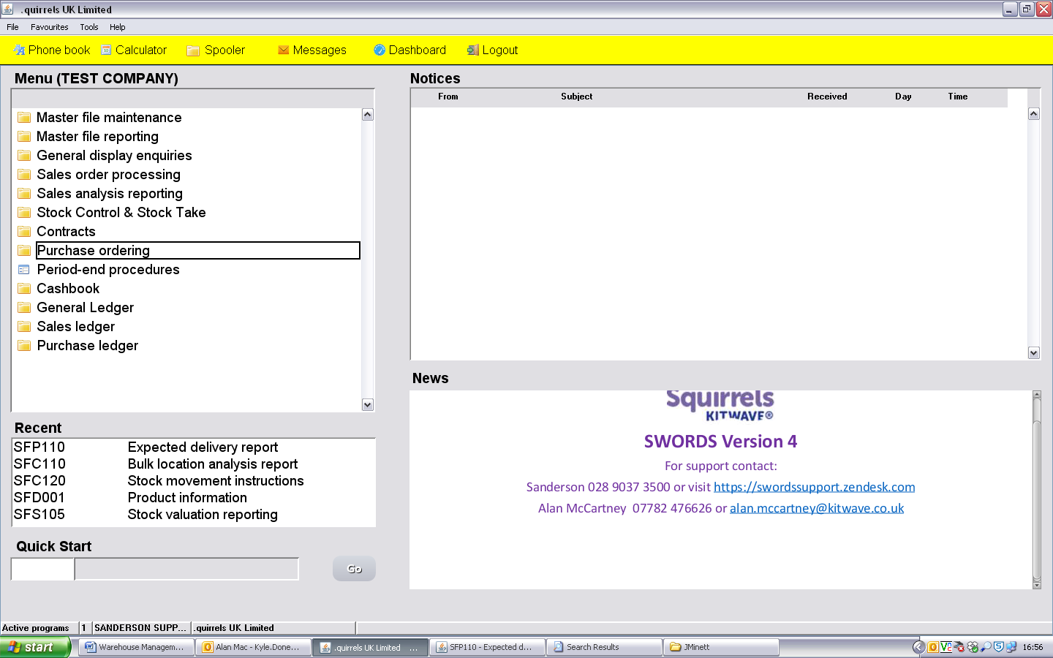
Select “Purchase order printing”
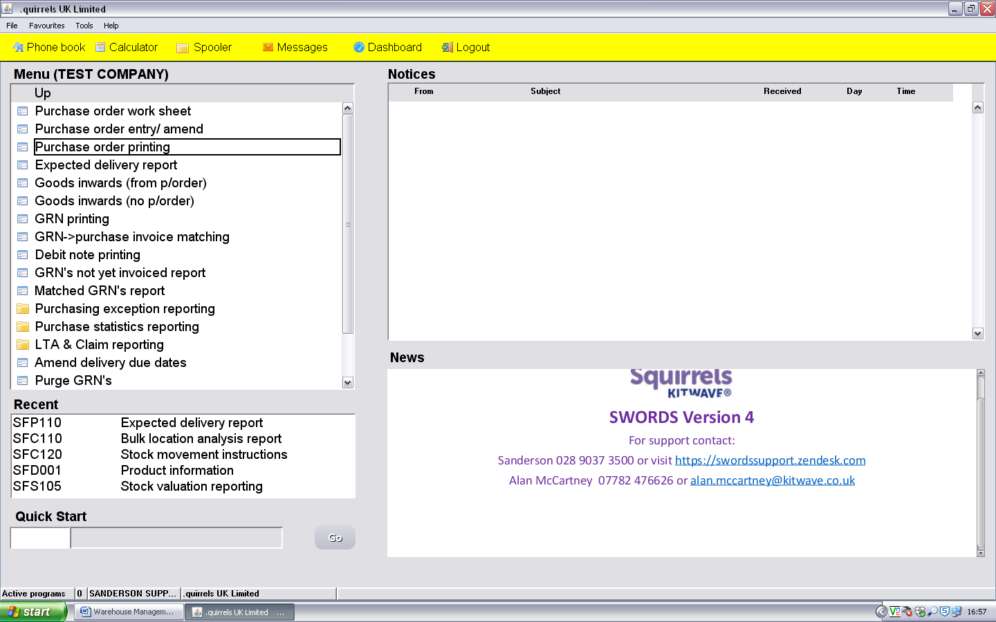
You will be asked for output selection, select “warehouse printer” and “print”
Always select “Reprint Documents”, and either enter the Document number you wish to re print, or select the due date range usually to match the expected delivery report. Remember to change the “from” and “to” boxes to the same date to print a day’s purchase orders. Then select print.
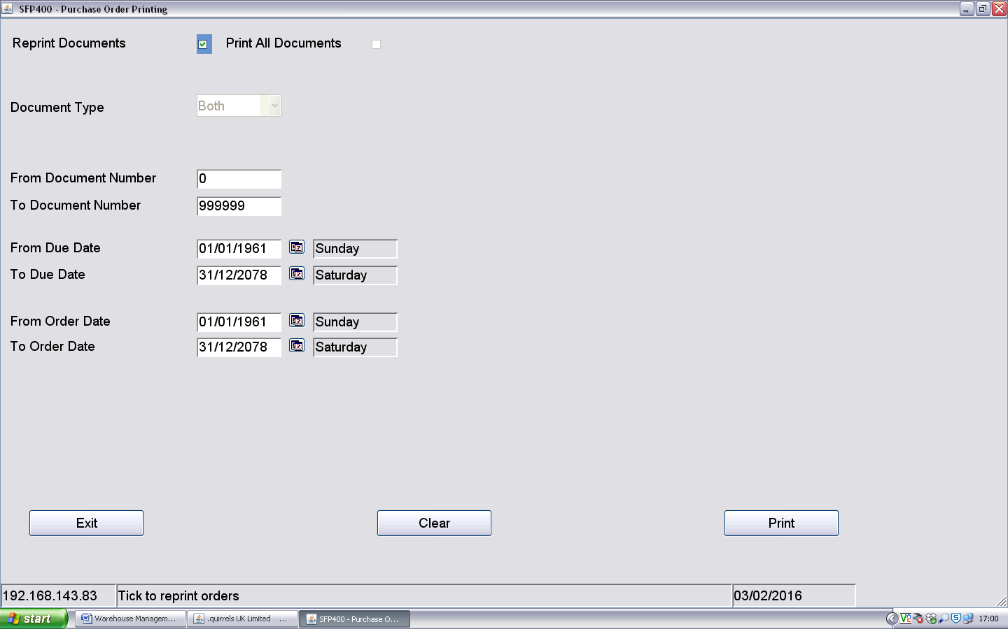
Please sign to say you understand and have completed the guide.
Name………………………………………… Manager…………………………………..
Signed………………………………………. Signed………………………………………
Date………………………………………….. Date………………………………………….

