Product enquiries and location searches.
At the end of day remove batteries and place in charger unit for the next morning.
Start of day, insert batteries, and press the PWR button and allow a minute to load up.
You will then be prompted to Log In: SQMN
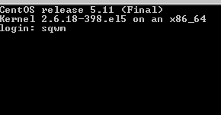
Then enter your Operator number and password, your name will appear confirming your number.
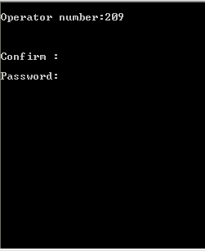
Confirm: Y
The following menu will appear:
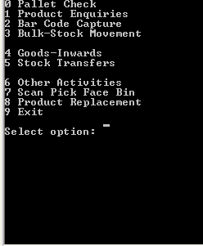
Enter “1” for Product enquiries

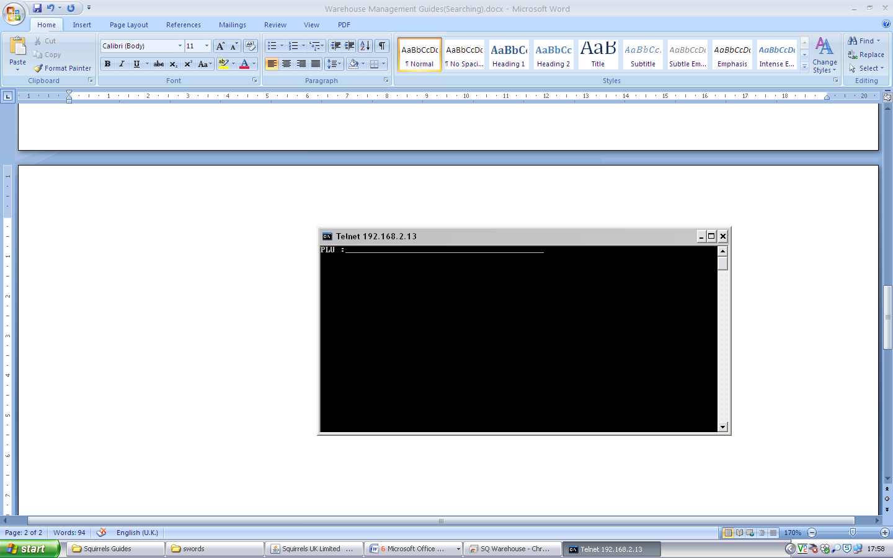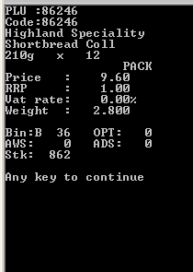
Scan Product barcode. Use this to check product details, including pick face location and total current stock.
Press any key to return to PLU:……. Screen. Press “CLR” to exit to main menu.
Enter “3” for Bulk-Stock Movement
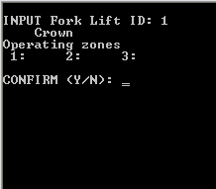
Enter “1” for fork lift ID, press Enter press Enter again and “Y” to confirm and continue to the next screen.
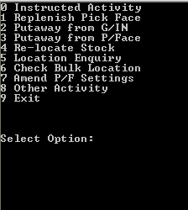
Select “5” for Location Enquiry or “6” to Check Bulk Location.
Location Enquiry
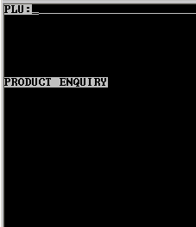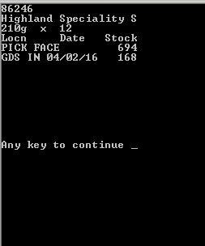
Scan Product barcode. Check product details are correct, if they are different then contact your manager to investigate.
This search can be used to find product details, pick face Quantity and all other Bulk locations including Goods in area.
Press any key to return to plu product scanning, and then “CLR” to exit to menu.
Check Bulk Location
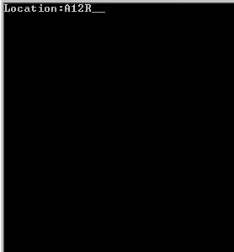
Scan Location barcode on Beams to the right of Bulk location you wish to search.
Press enter to see All goods at that location. Press enter to return to Location scanning screen. Then press “CLR” to exit to menu.

Please sign to accept that you understand and have completed the training on the above.
Name ……………………………………………………… Managers Name………………………………………
Signature………………………………………………… Managers Signature………………………………..
Date………………………………………………………… Date…………………………………………………………

