Bulk Locations Check
This guide will explain in detail how to check which bulk locations are occupied or empty including Goods In.

- From SWORDS main menu double click on Stock Control & Stock Take
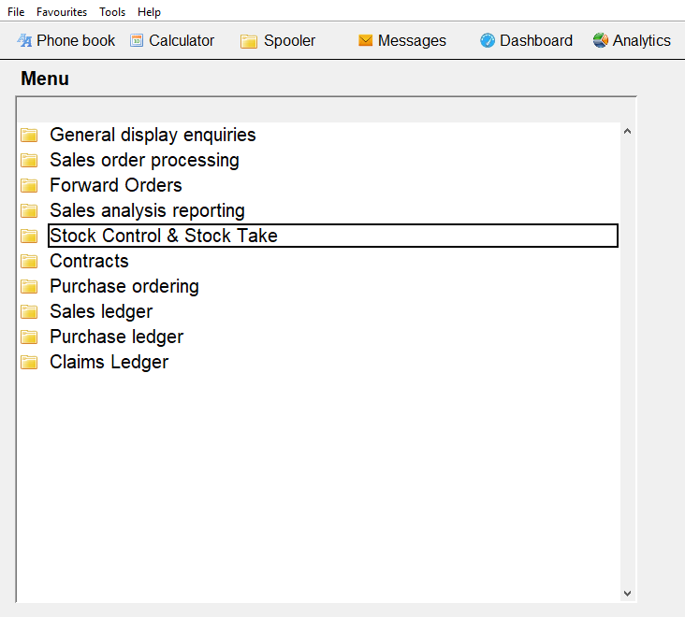

- Then double click on Warehouse Management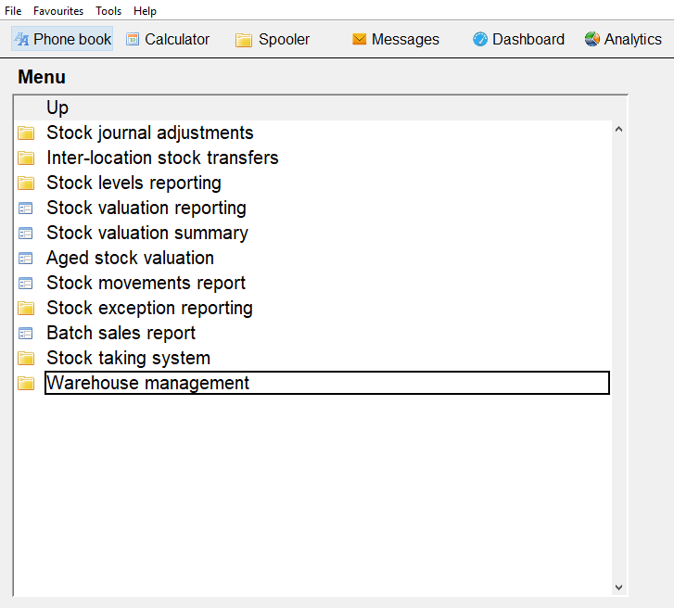

- Then double click on Bulk analysis / BBE report
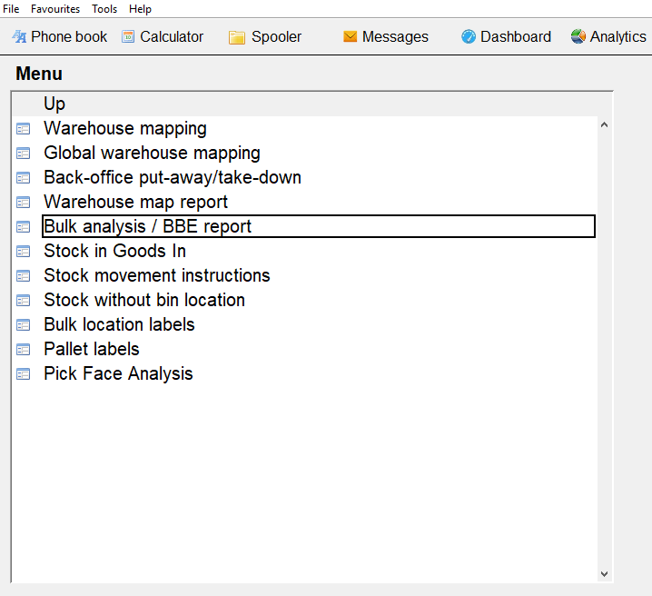

- Then choose from the middle drop down box at the top of the page what you want to report on.
All locations will report on All locations in the Warehouse including Goods In
Empty Locations will report on empty or free bulk locations in the Warehouse including Goods In.
Occupied Locations will report on locations that have stock.

For the purpose of this guide we have selected ‘All locations’.

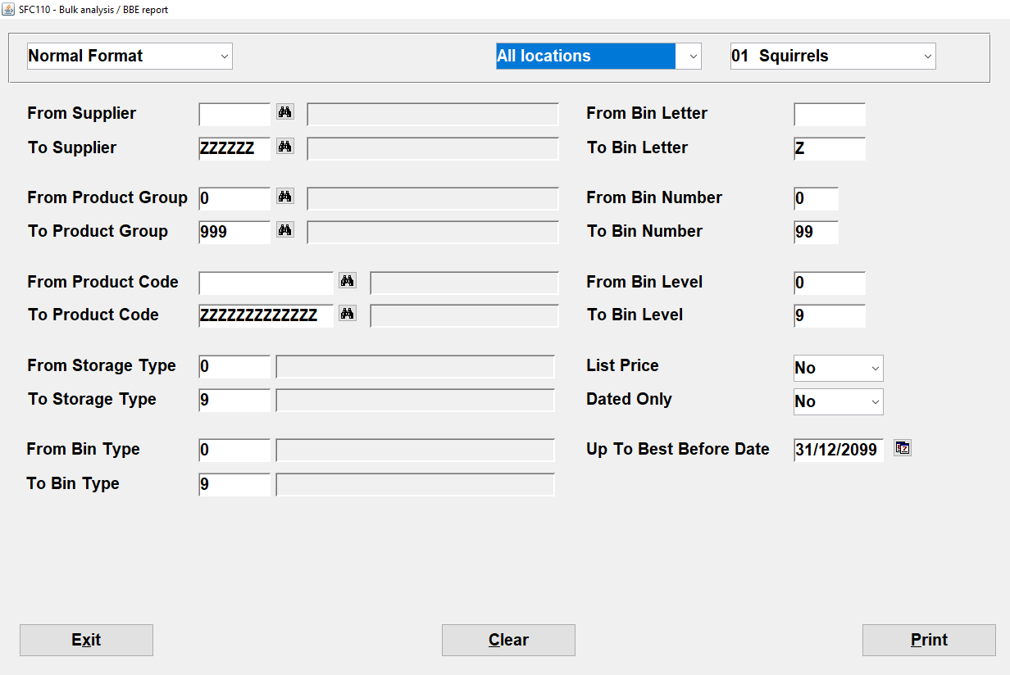

Once you have chosen your reporting criteria, click on Print the choose Excel
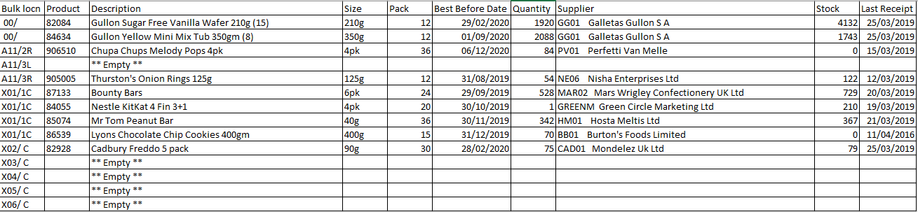

This report shows:
Bulk Location (Bulk locn)
Product Code (Product)
Product Description (Description)
Product Unit Size (Size)
Product Units per case (Pack)
Best Before Date
Quantity
Supplier
Stock in the location (Stock)
Last time the product was receipted in Goods In (Lat Receipt)

Bulk Location 00/ is the location for Goods In. There should be no stock in Goods In at the end of the day as all deliveries should have been put away to Bulk which is X01/1C, X02/0C, X03/0C, X04/0C, X05/0C and X06/0C and then moved to a Bulk location or Pick Face within the Warehouse.

