Bulk Location Barcode Labels
This guide will explain in detail how to print Bulk Location Barcode Labels that are normally positioned on the bay uprights.

- From SWORDS main menu double click on Stock Control & Stock Take
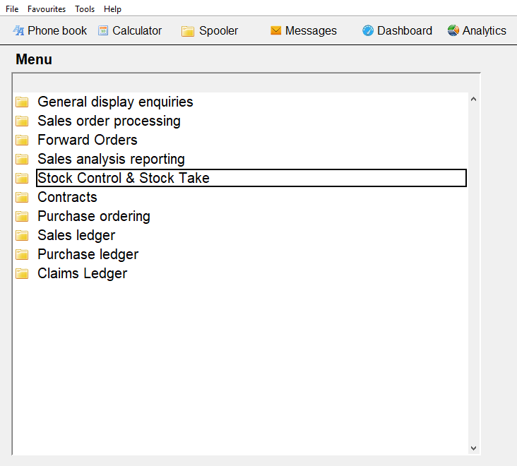

- Then double click on Warehouse Management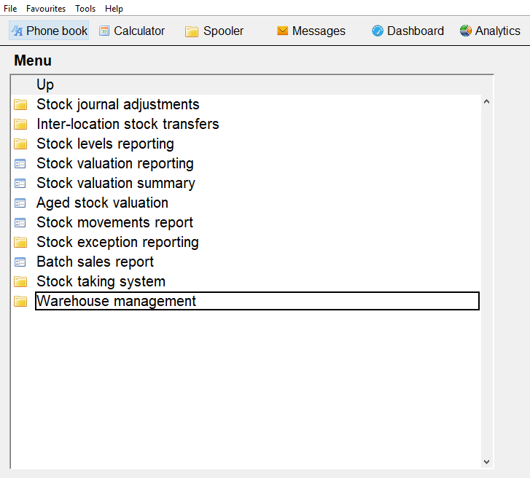

- Then double click on Bulk location labels
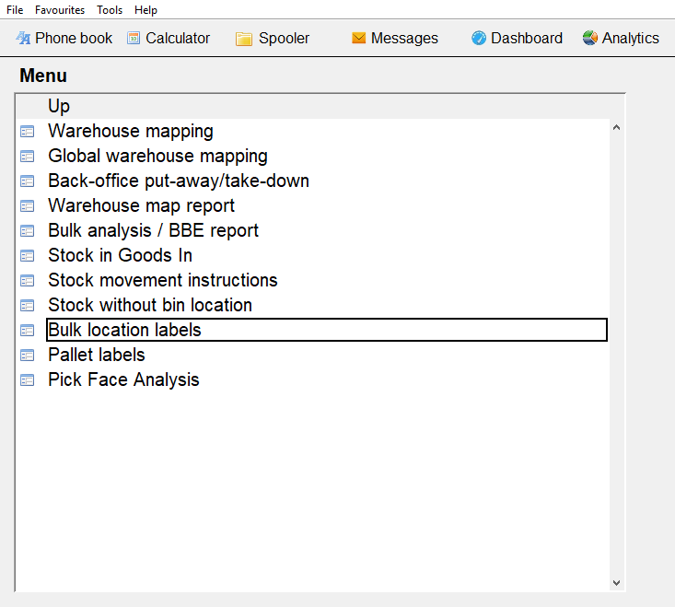

- Below is the criteria to print labels for all of location A01
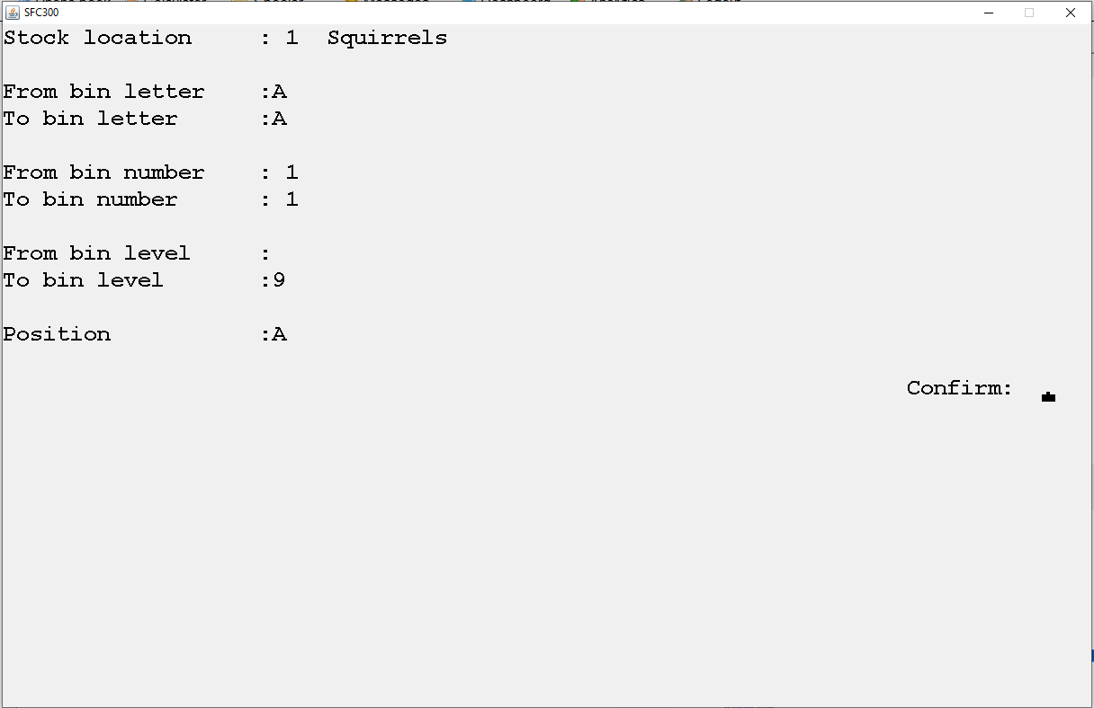

You can select labels for more than one bay, for example if you wanted to print labels for bay A01 to bay A06, you would input From bin number: 1 To bin number: 6 (Example below)
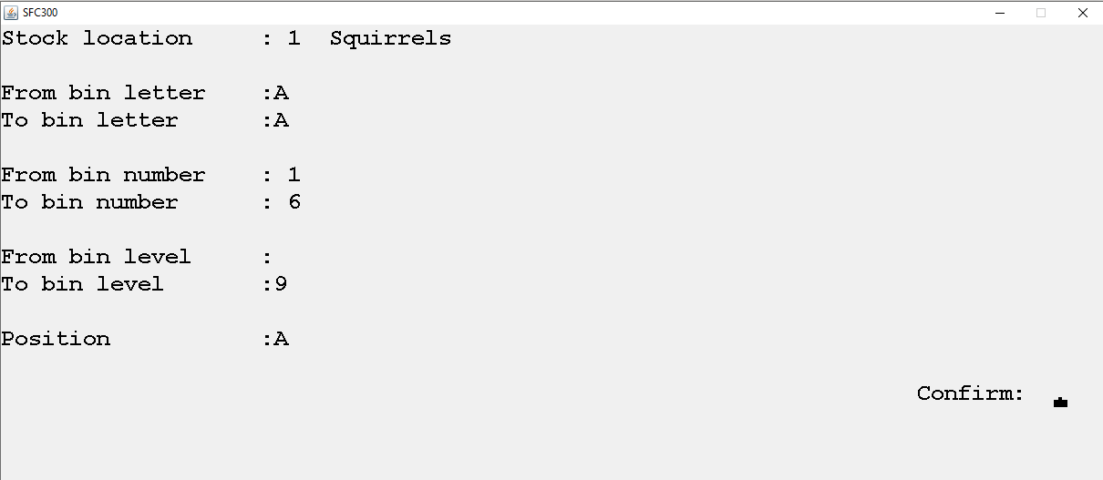

You can run labels based on the bin number, level and position of the location. Then press Y to confirm.

- From the drop-down list, select Label Printer and then click on Print
